**1-Database Operations**

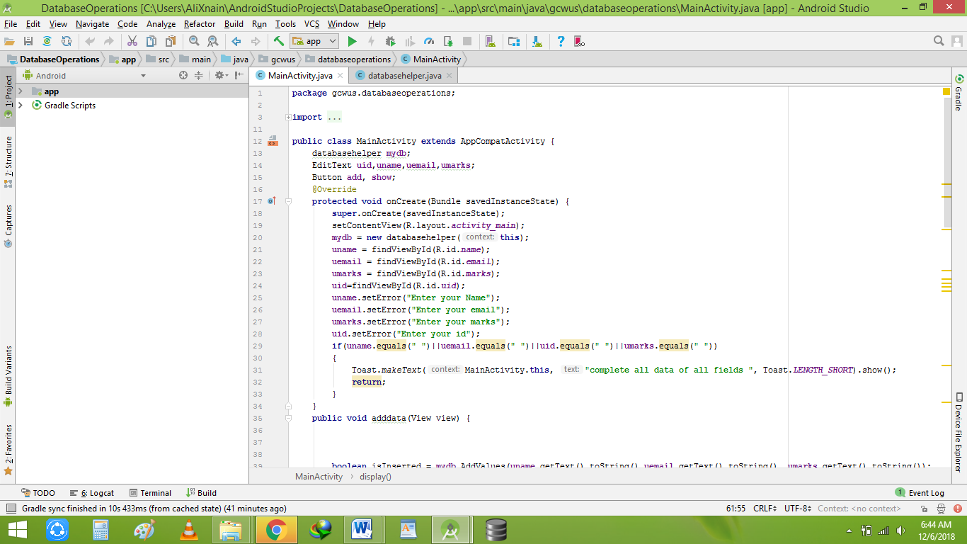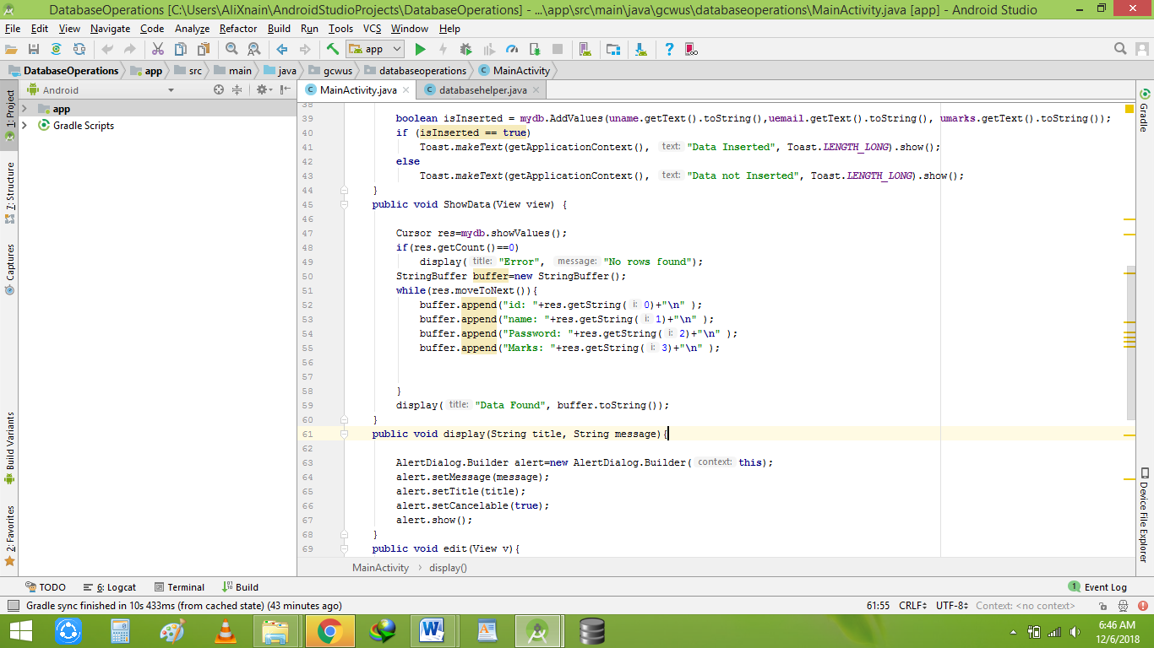

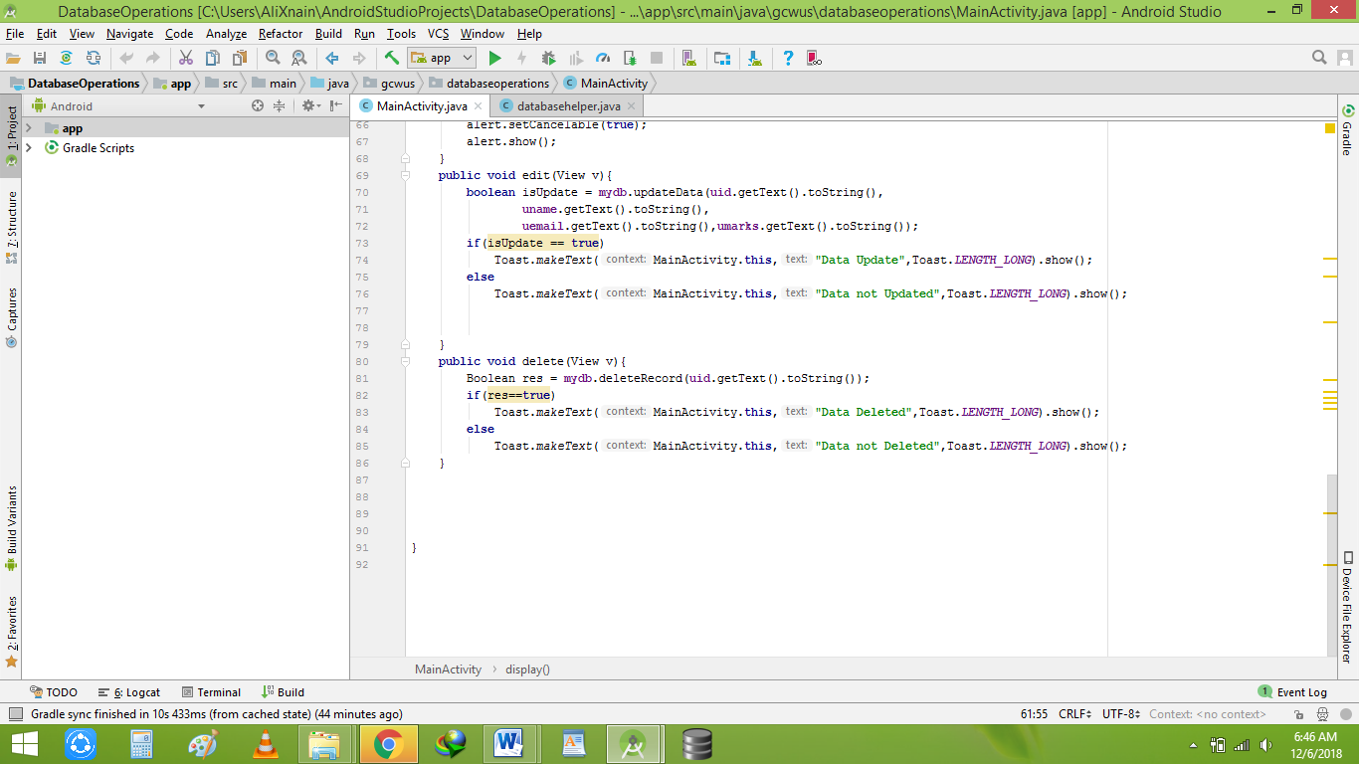

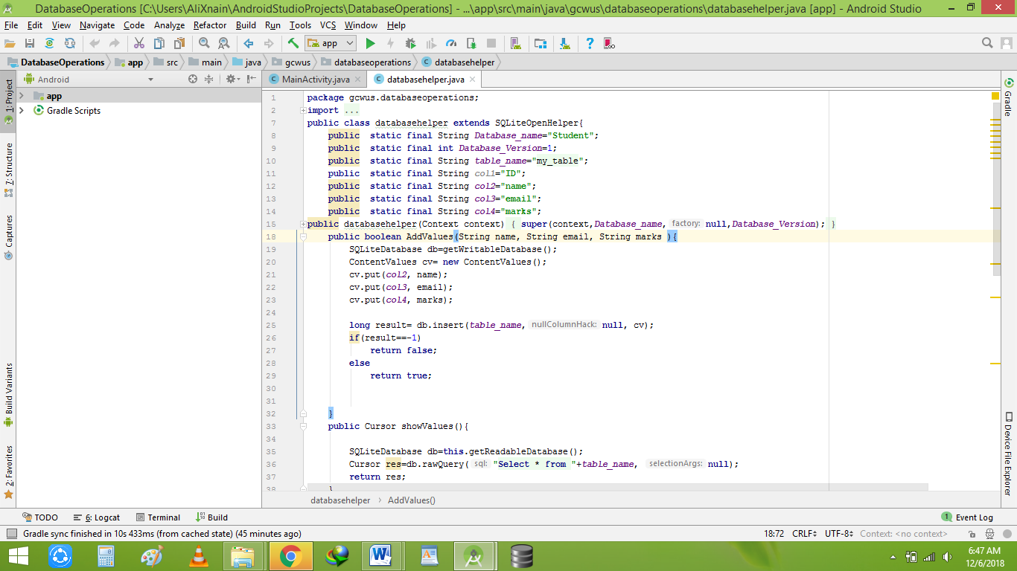

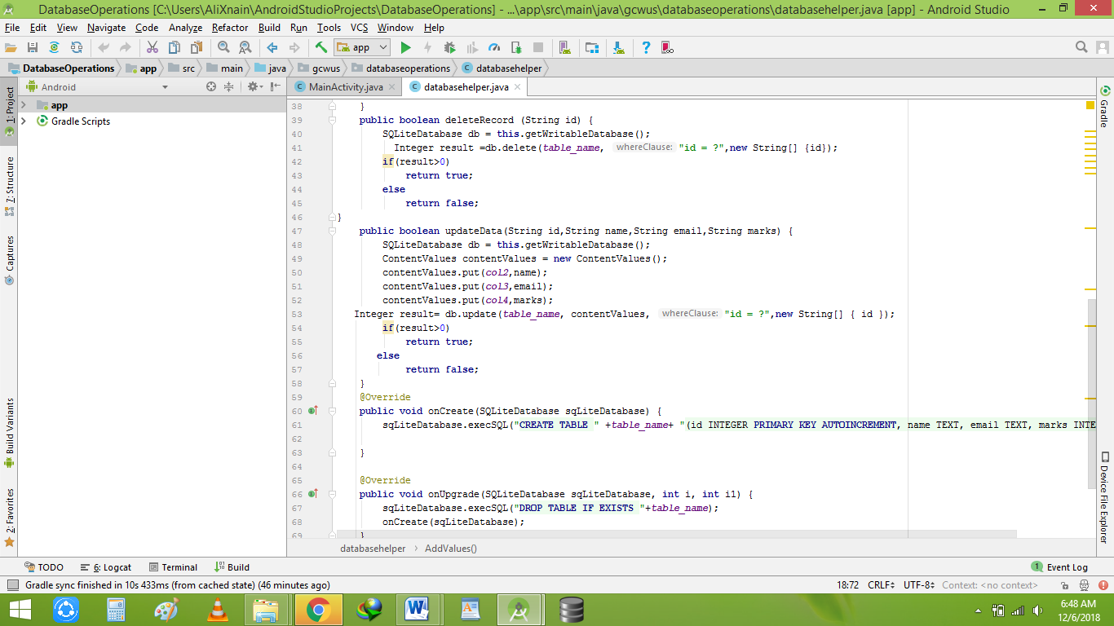

**2-** **Popup menu**

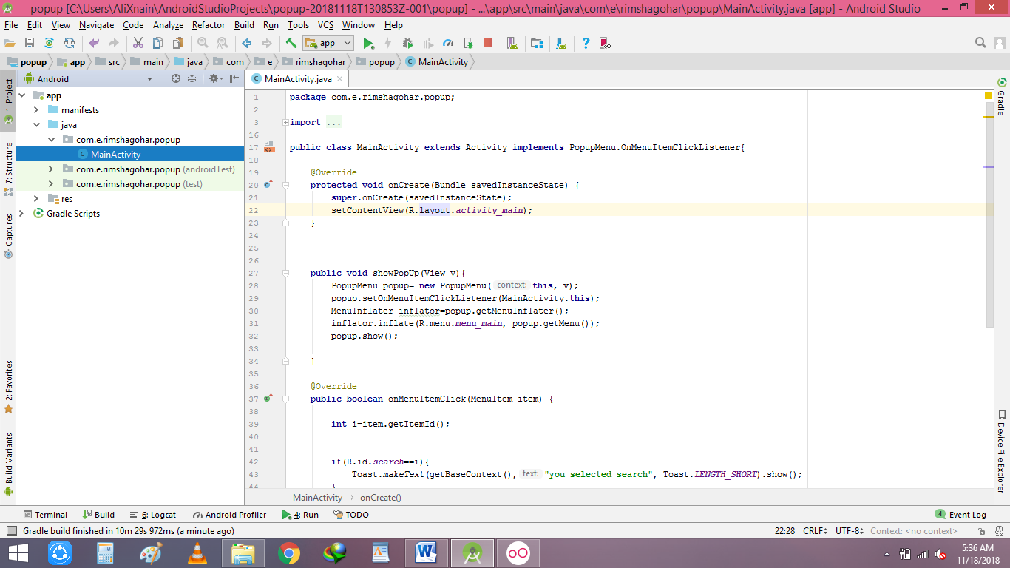

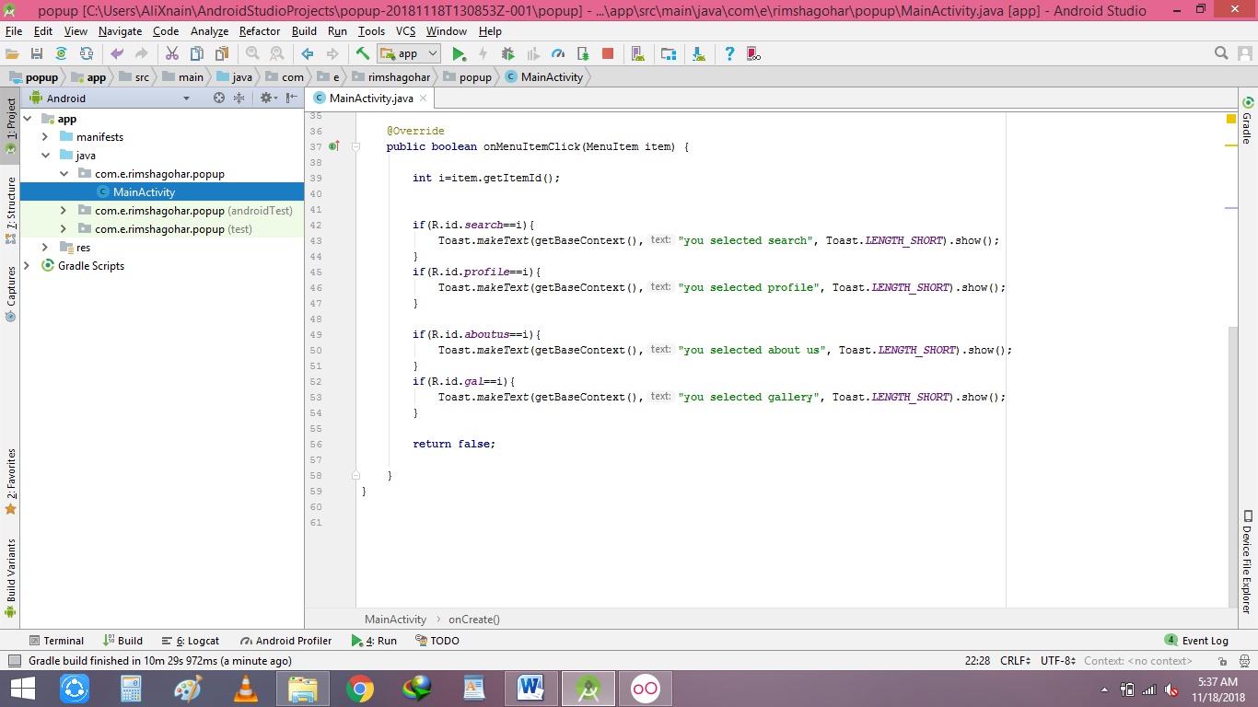

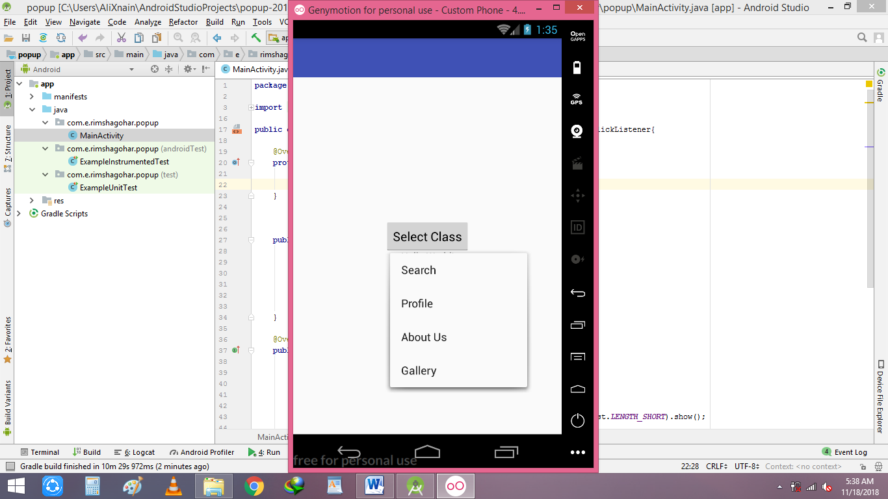 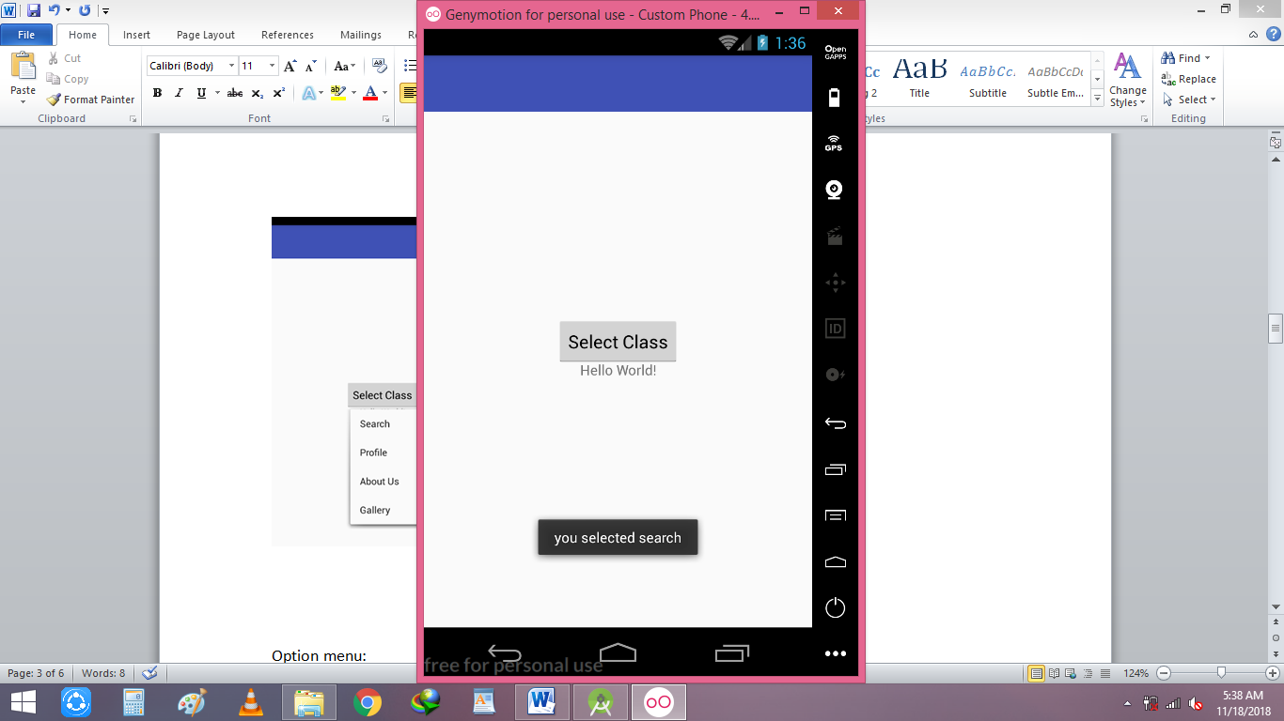

**Option menu:**

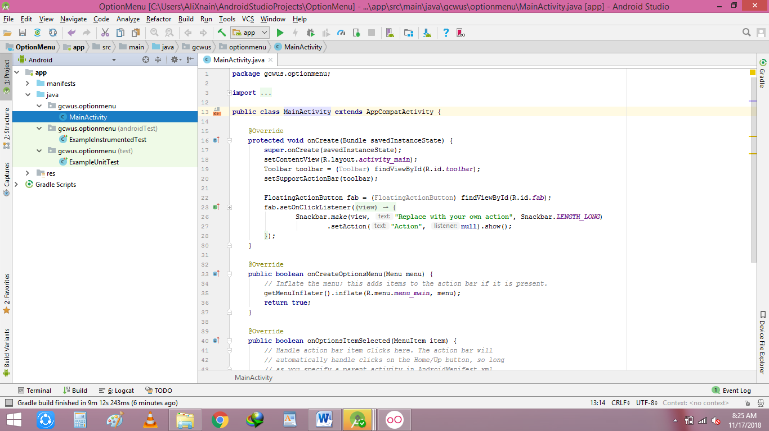

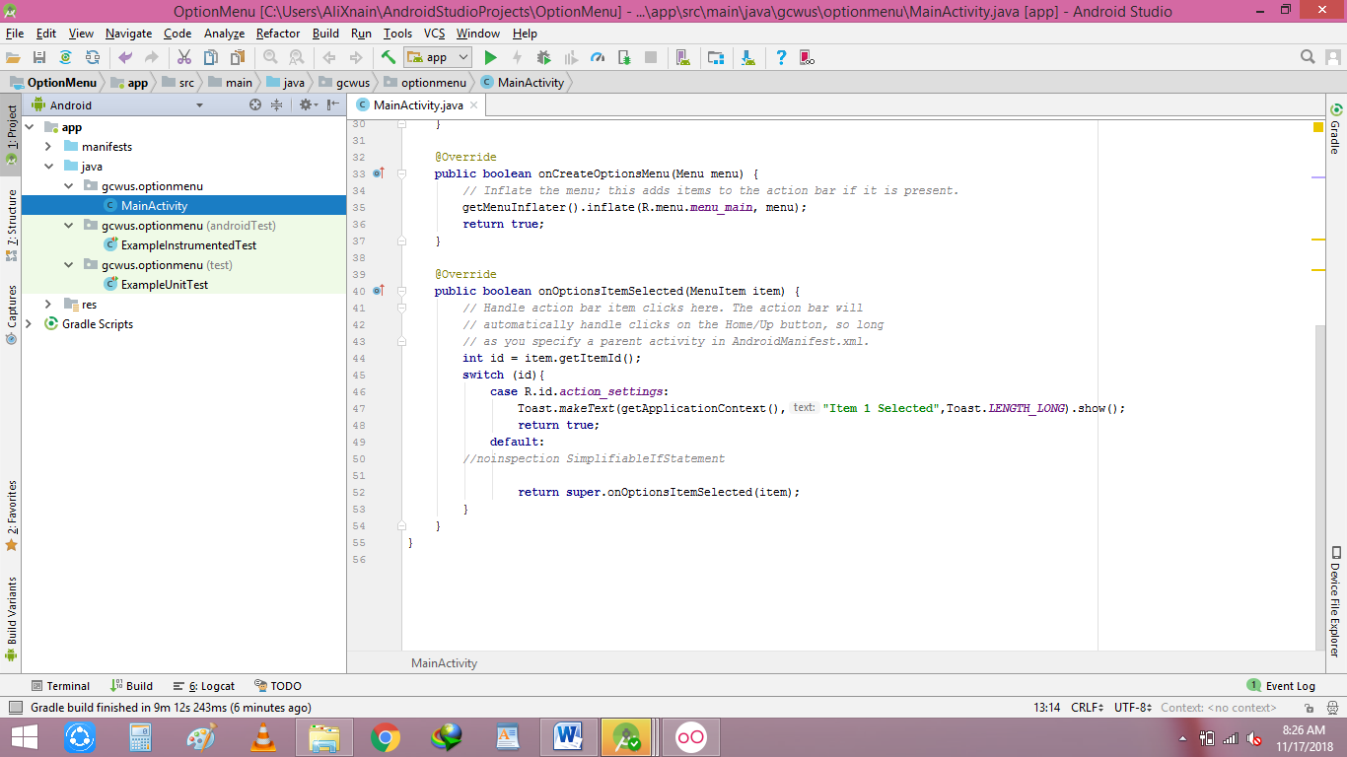

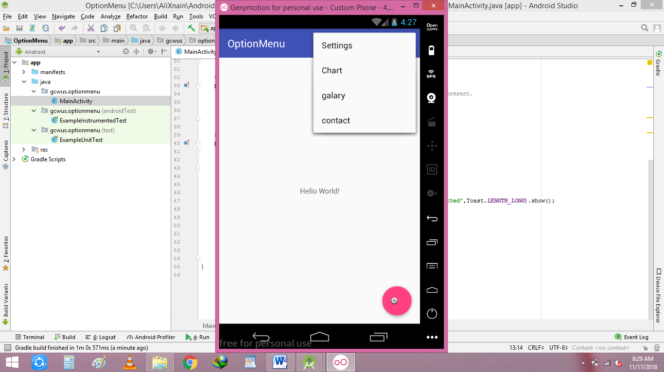

**Context menu:**

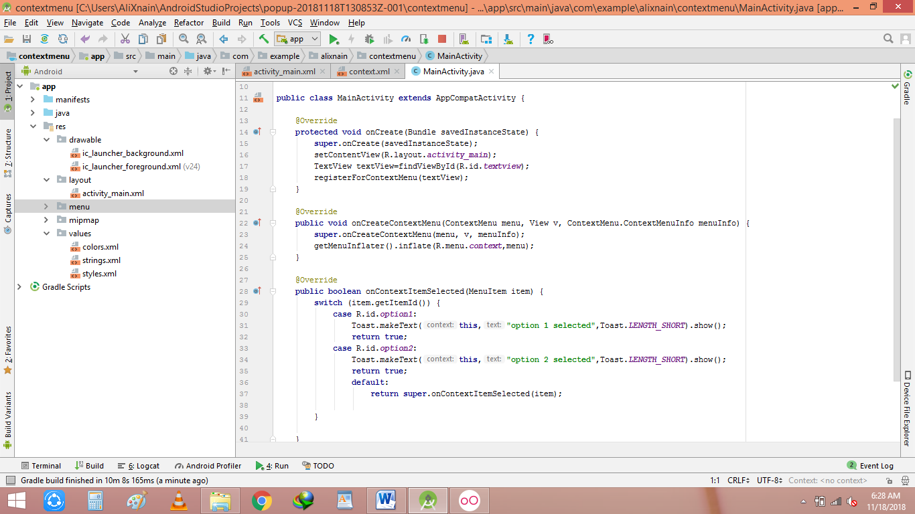

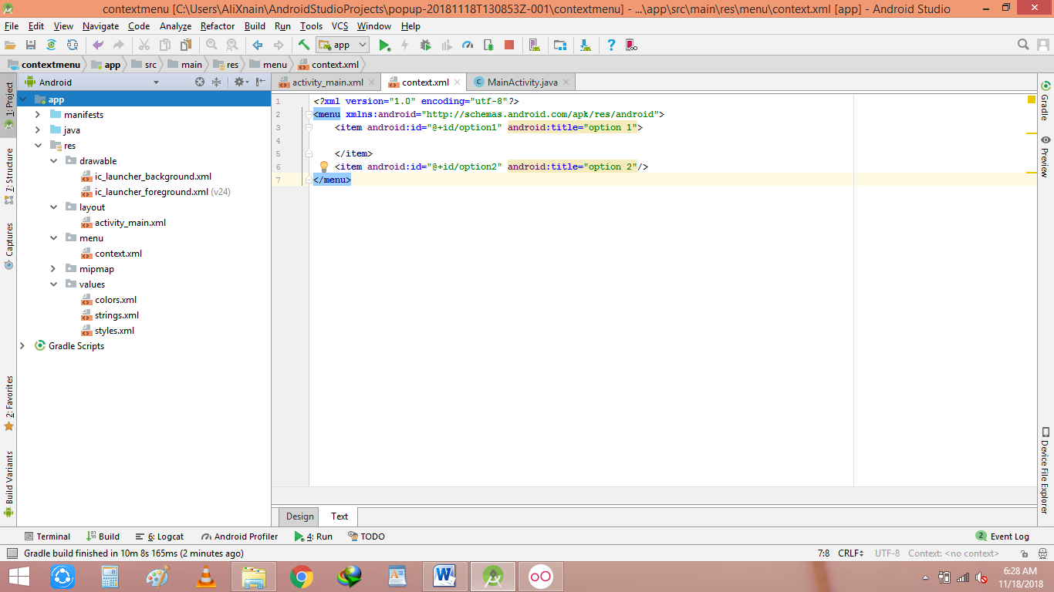

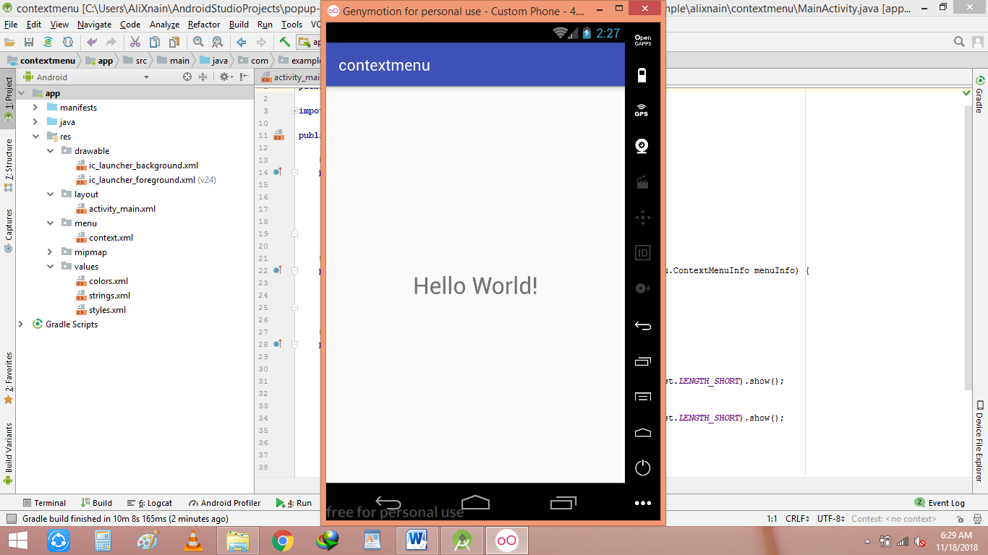 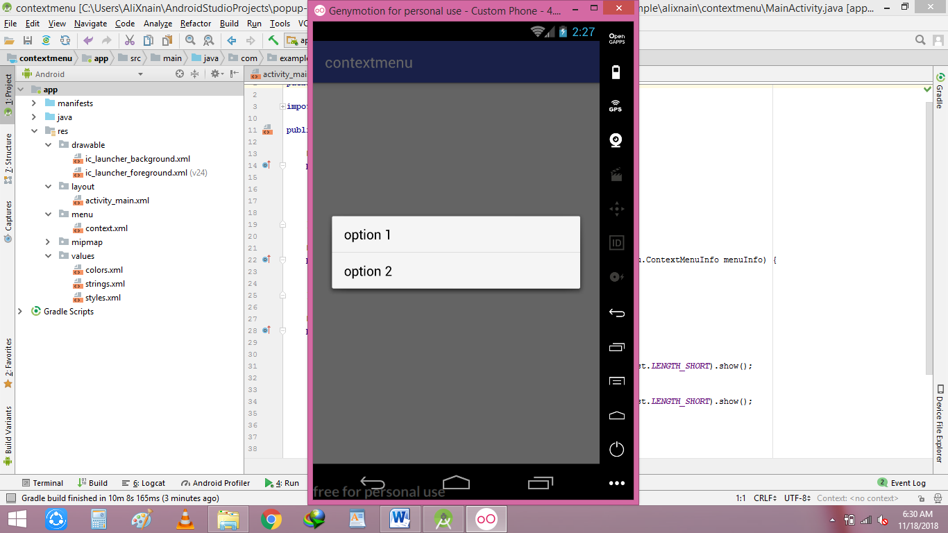 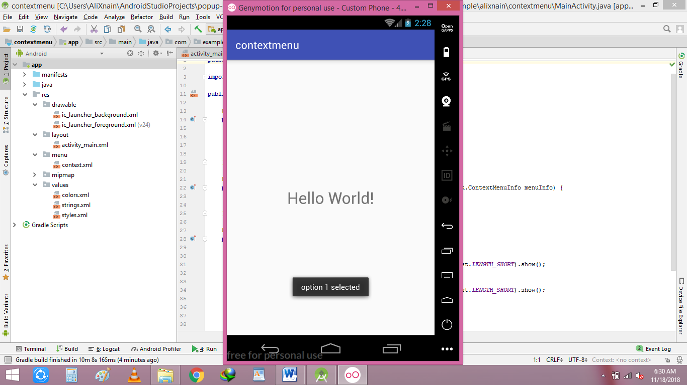

**Static fragment**:

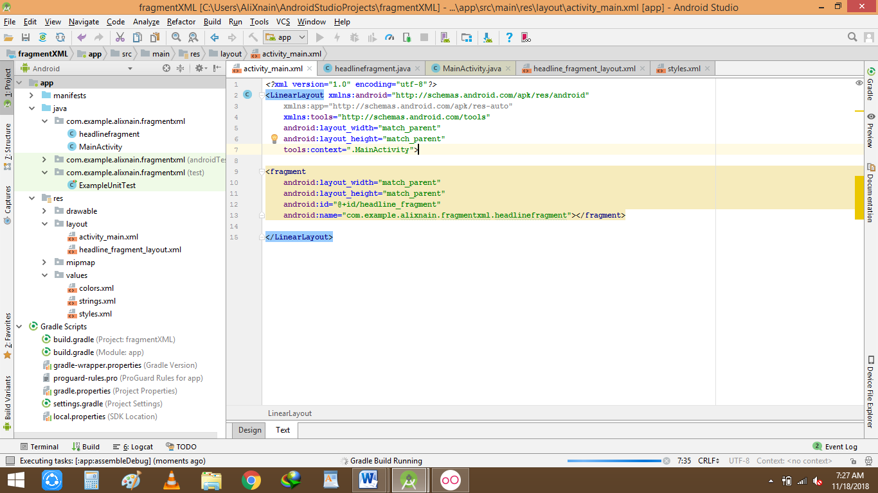

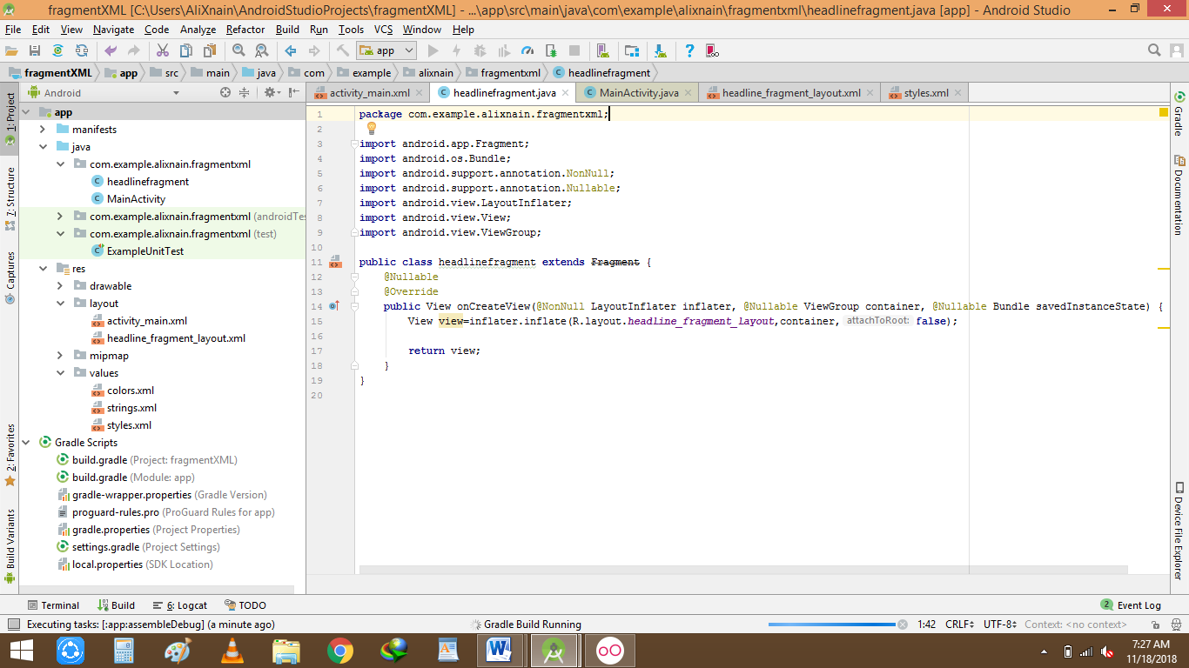

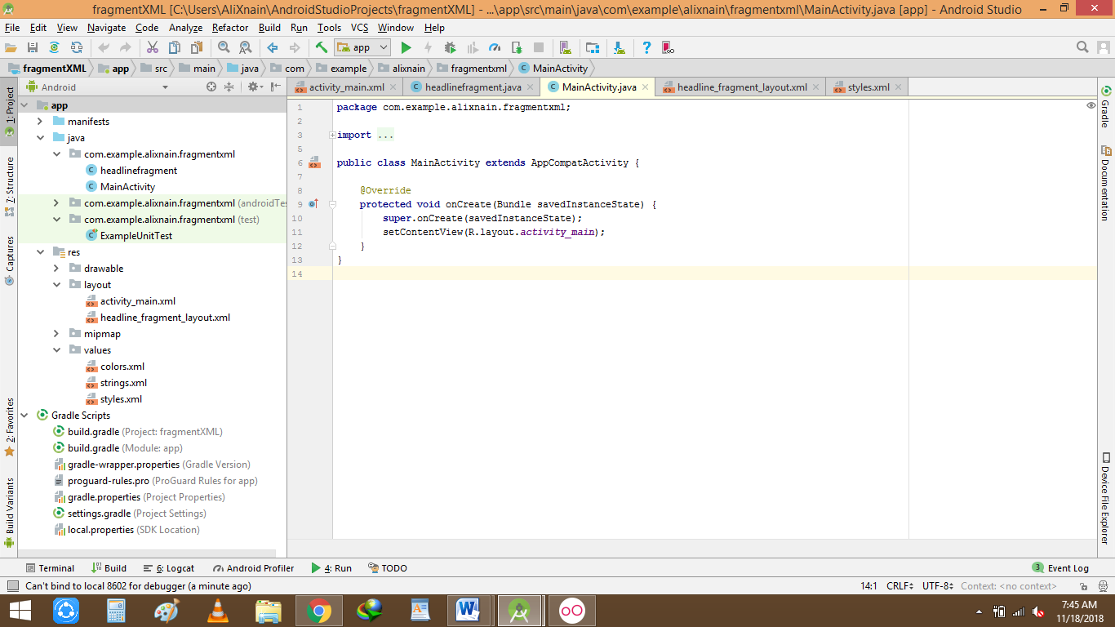

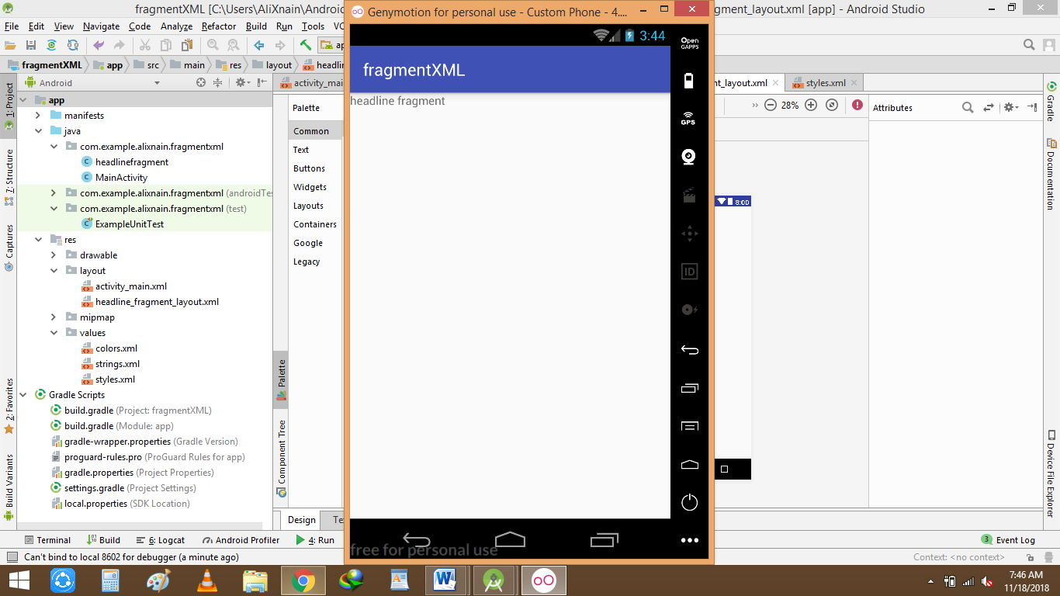

**Dynamic Fragment:**

**Main.java**

**package** com.example.alixnain.fragment;  
  
**import** android.os.Bundle;  
**import** android.support.design.widget.FloatingActionButton;  
**import** android.support.design.widget.Snackbar;  
**import** android.support.v4.app.FragmentManager;  
**import** android.support.v7.app.ActionBar;  
**import** android.view.View;  
**import** android.support.design.widget.NavigationView;  
**import** android.support.v4.view.GravityCompat;  
**import** android.support.v4.widget.DrawerLayout;  
**import** android.support.v7.app.ActionBarDrawerToggle;  
**import** android.support.v7.app.AppCompatActivity;  
**import** android.support.v7.widget.Toolbar;  
**import** android.view.Menu;  
**import** android.view.MenuItem;  
**import** android.support.v4.app.Fragment;  
  
**public class** MainActivity **extends** AppCompatActivity **implements** NavigationView.OnNavigationItemSelectedListener {  
  
  
 @Override  
 **protected void** onCreate(Bundle savedInstanceState) {  
 **super**.onCreate(savedInstanceState);  
 setContentView(R.layout.activity_main);  
 Toolbar toolbar = (Toolbar) findViewById(R.id.toolbar);  
 setSupportActionBar(toolbar);  
  
 FloatingActionButton fab = (FloatingActionButton) findViewById(R.id.fab);  
 fab.setOnClickListener(**new** View.OnClickListener() {  
 @Override  
 **public void** onClick(View view) {  
 Snackbar.make(view, **"Replace with your own action"**, Snackbar.LENGTH_LONG)  
 .setAction(**"Action"**, **null**).show();  
 }  
 });  
  
 DrawerLayout drawer = (DrawerLayout) findViewById(R.id.drawer_layout);  
 ActionBarDrawerToggle toggle = **new** ActionBarDrawerToggle(  
 **this**, drawer, toolbar, R.string.navigation_drawer_open, R.string.navigation_drawer_close);  
 drawer.addDrawerListener(toggle);  
 toggle.syncState();  
  
 NavigationView navigationView = (NavigationView) findViewById(R.id.nav_view);  
 navigationView.setNavigationItemSelectedListener(**this**);  
 }  
  
 @Override  
 **public void** onBackPressed() {  
 DrawerLayout drawer = (DrawerLayout) findViewById(R.id.drawer_layout);  
 **if** (drawer.isDrawerOpen(GravityCompat.***START***)) {  
 drawer.closeDrawer(GravityCompat.***START***);  
 } **else** {  
 **super**.onBackPressed();  
 }  
 }  
  
 @Override  
 **public boolean** onCreateOptionsMenu(Menu menu) {  
 *// Inflate the menu; this adds items to the action bar if it is present.* getMenuInflater().inflate(R.menu.main, menu);  
 **return true**;  
 }  
  
 @Override  
 **public boolean** onOptionsItemSelected(MenuItem item) {  
 *// Handle action bar item clicks here. The action bar will  
 // automatically handle clicks on the Home/Up button, so long  
 // as you specify a parent activity in AndroidManifest.xml.* **int** id = item.getItemId();  
  
 *//noinspection SimplifiableIfStatement* **if** (id == R.id.action_settings) {  
 **return true**;  
 }  
  
 **return super**.onOptionsItemSelected(item);  
 }  
  
 @SuppressWarnings(**"StatementWithEmptyBody"**)  
 @Override  
 **public boolean** onNavigationItemSelected(MenuItem item) {  
 *// Handle navigation view item clicks here.* **int** id = item.getItemId();  
  
 **if** (id == R.id.nav_camera) {  
 firstFragment firstFragment=**new** firstFragment();  
 FragmentManager fragmentManager=getSupportFragmentManager();  
 fragmentManager.beginTransaction().replace(R.id.fragment1, **null**).commit();  
 } **else if** (id == R.id.nav_gallery) {  
  
 } **else if** (id == R.id.nav_slideshow) {  
  
 } **else if** (id == R.id.nav_manage) {  
  
 } **else if** (id == R.id.nav_share) {  
  
 } **else if** (id == R.id.nav_send) {  
  
 }  
  
 DrawerLayout drawer = (DrawerLayout) findViewById(R.id.drawer_layout);  
 drawer.closeDrawer(GravityCompat.***START***);  
 **return true**;  
 }  
}

**firstfragment.java(only create this file)**

**SNACKBAR:**

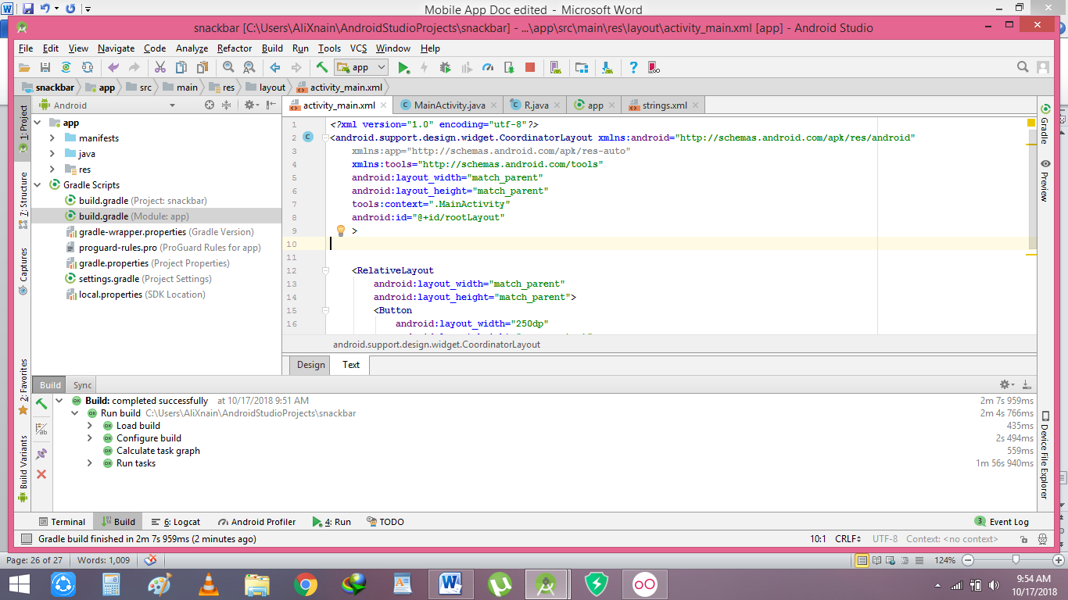

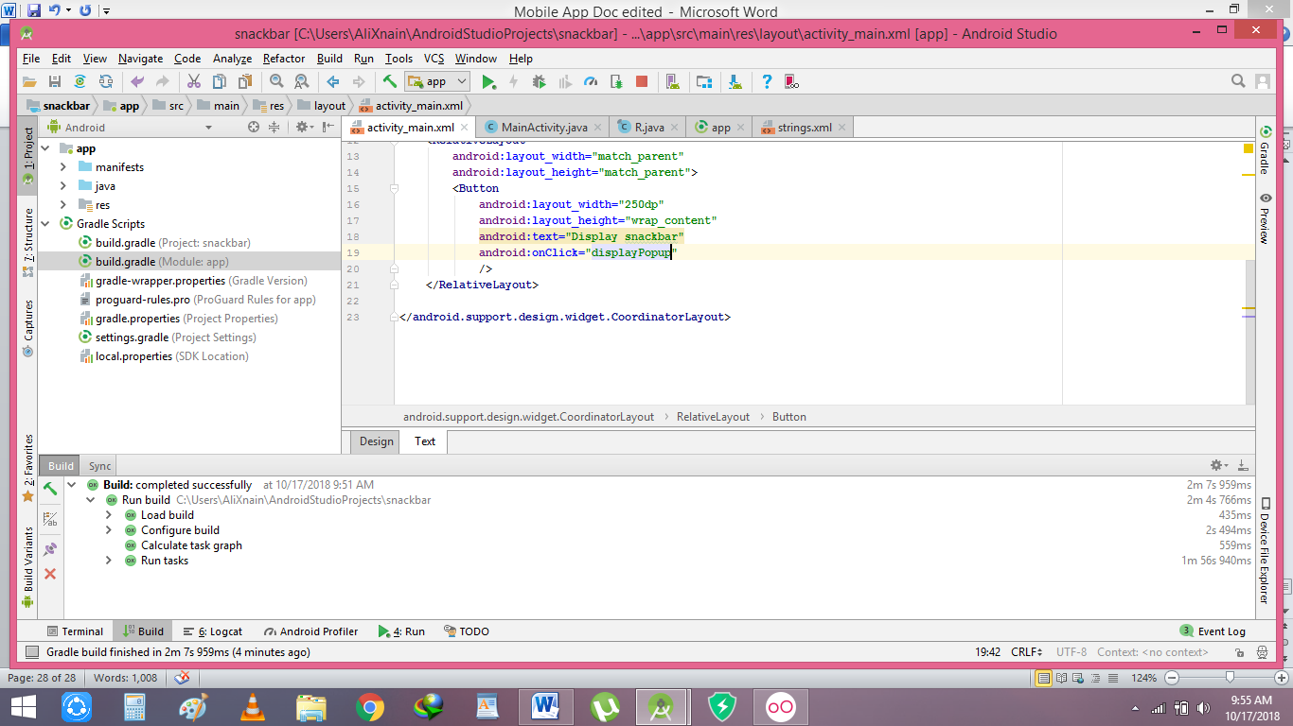

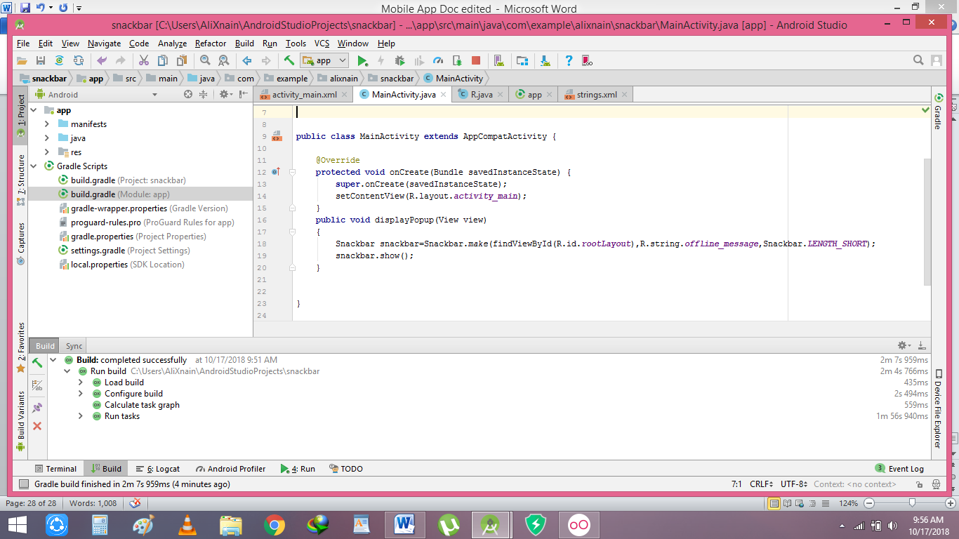

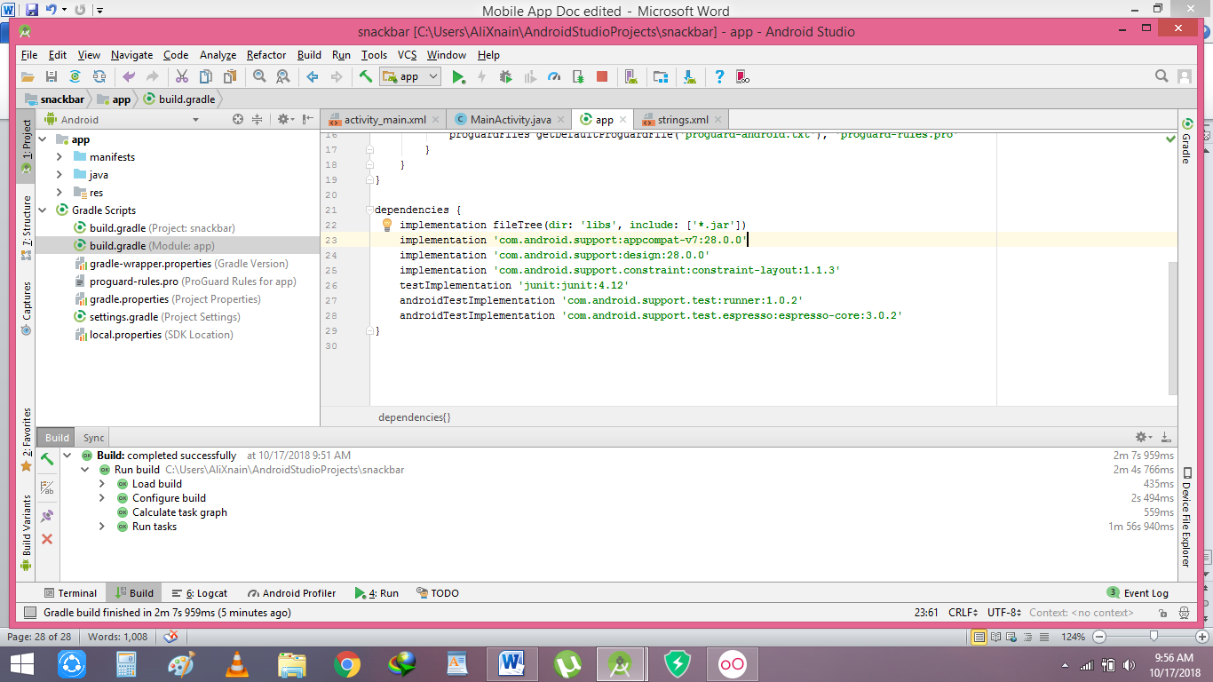

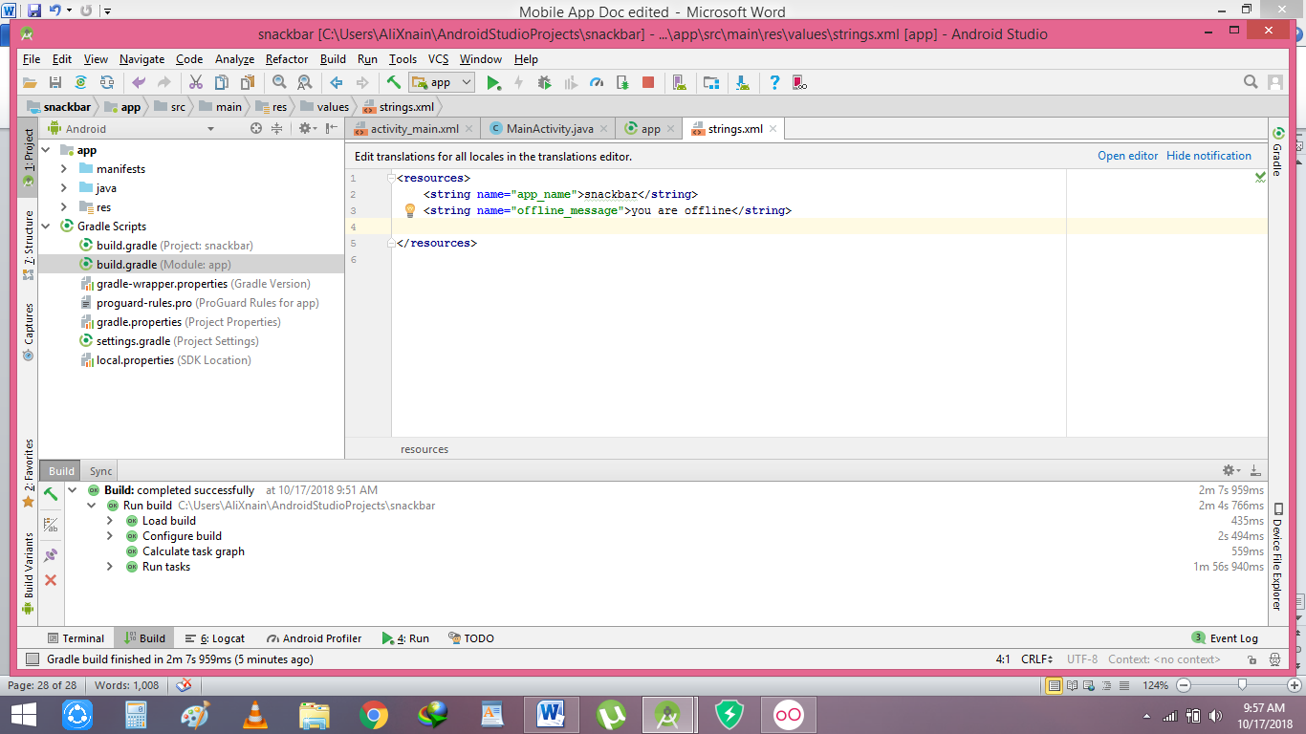

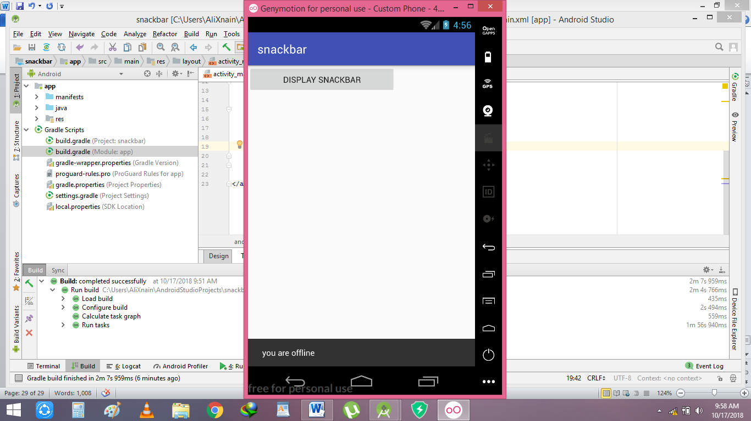

**Spinners:**

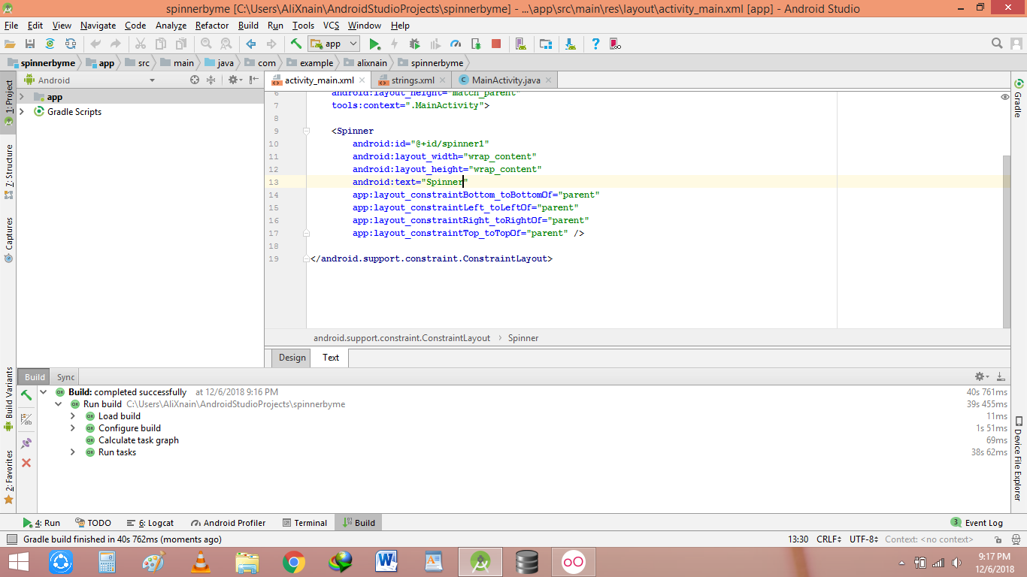

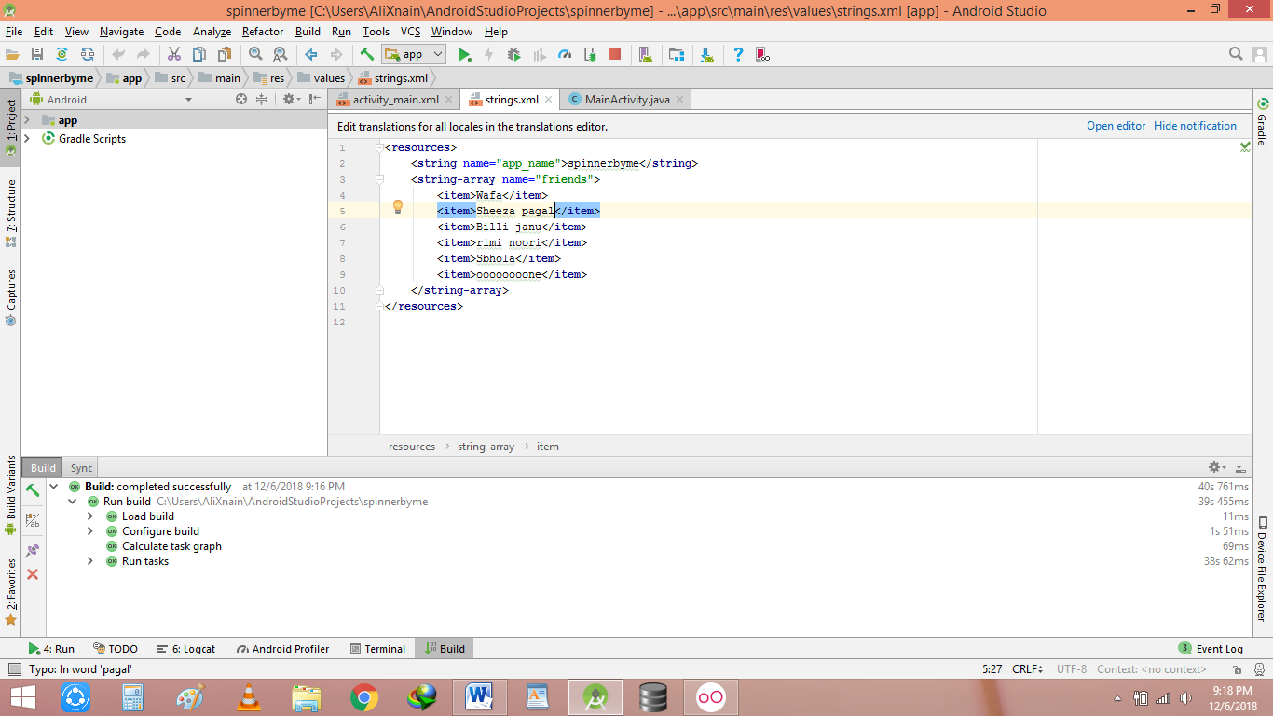

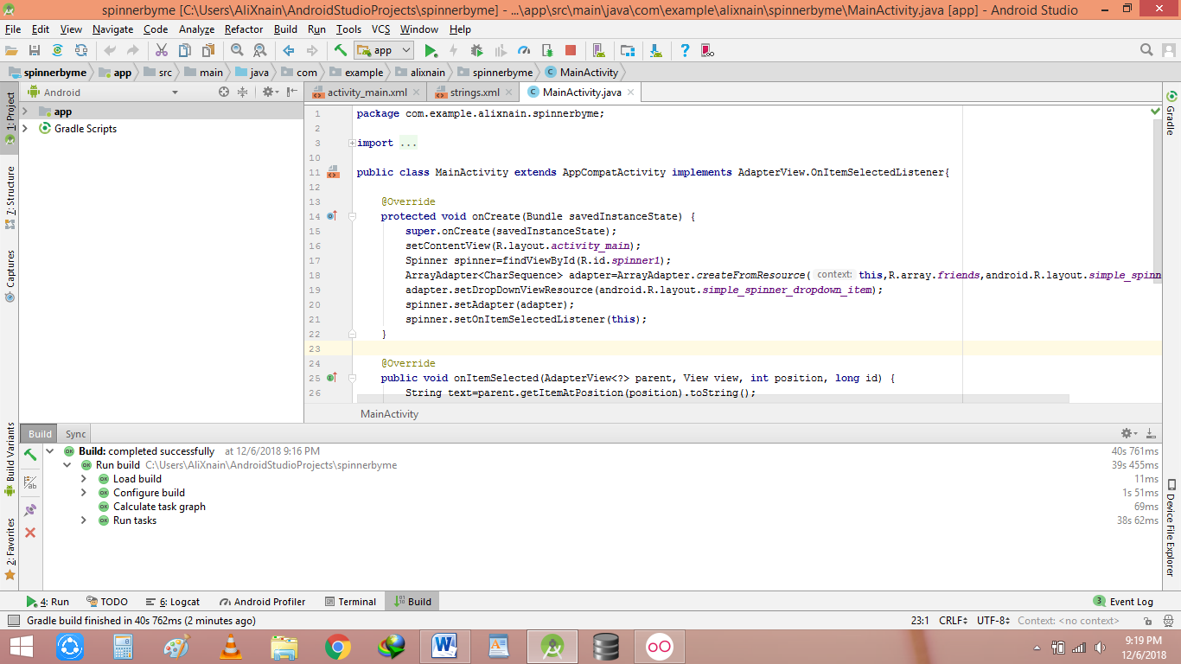

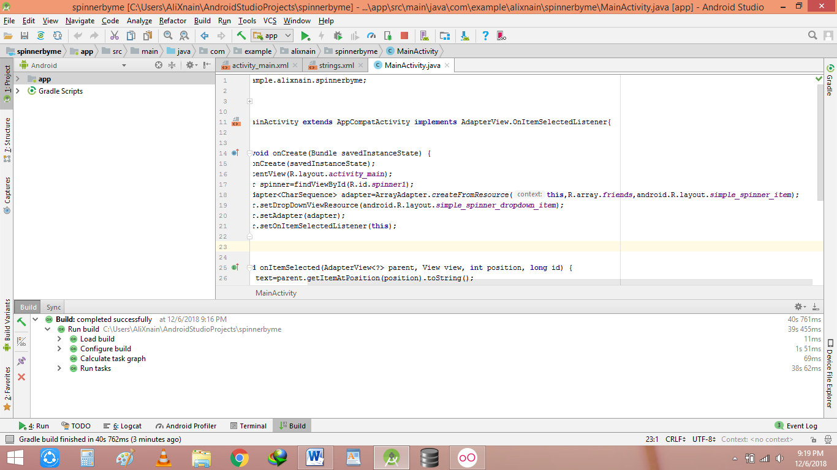

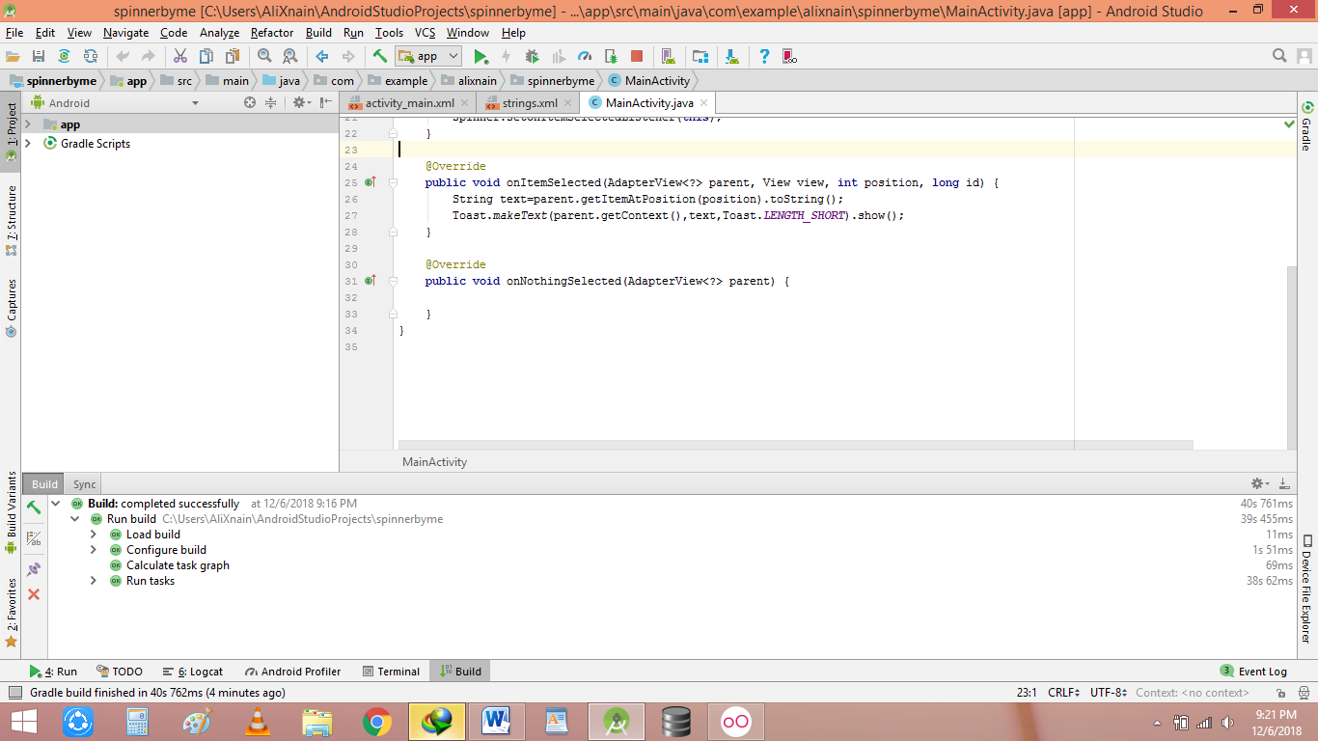

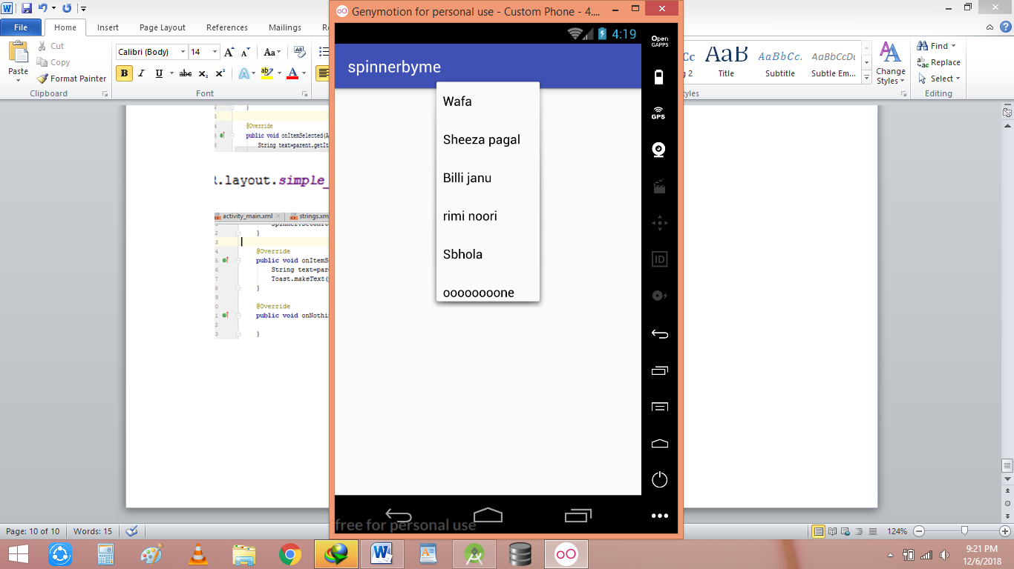

**Pageviewer:**

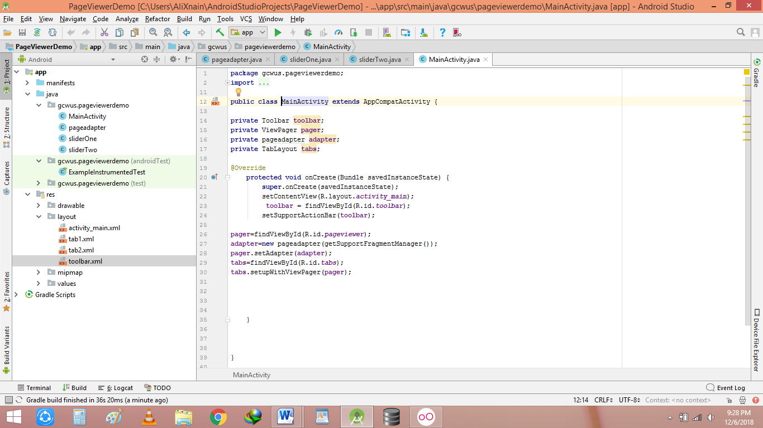

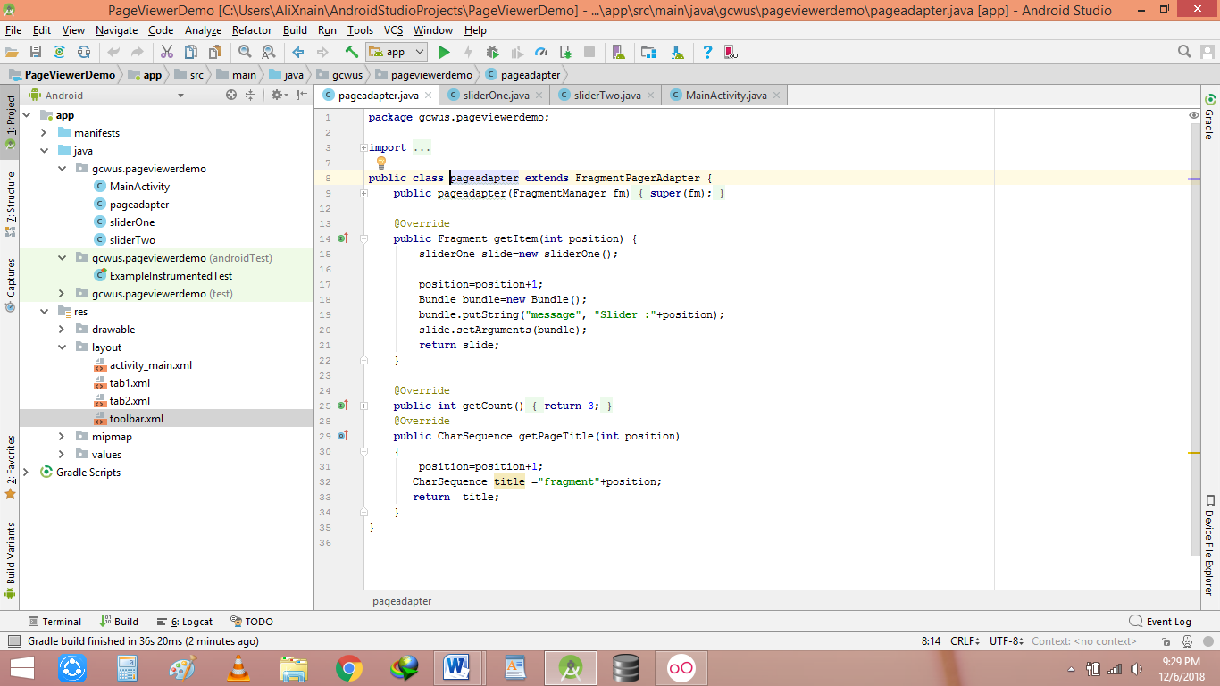

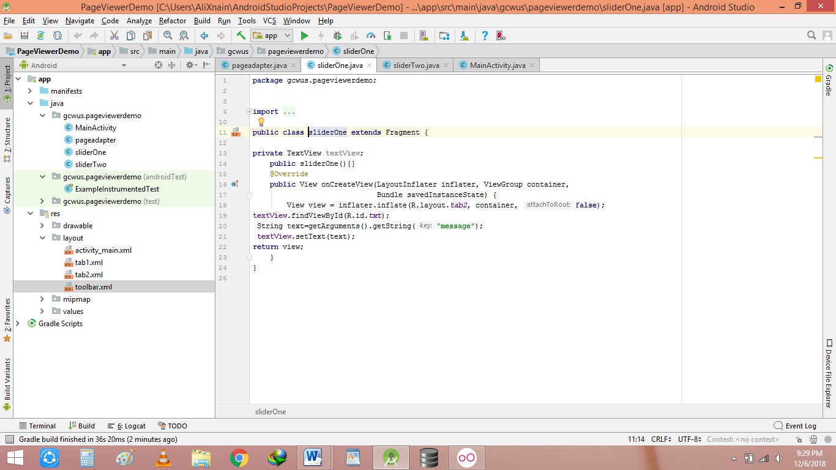

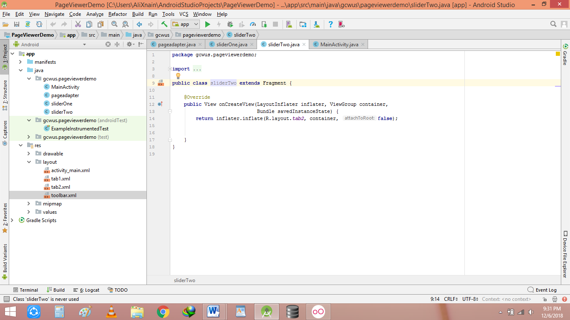

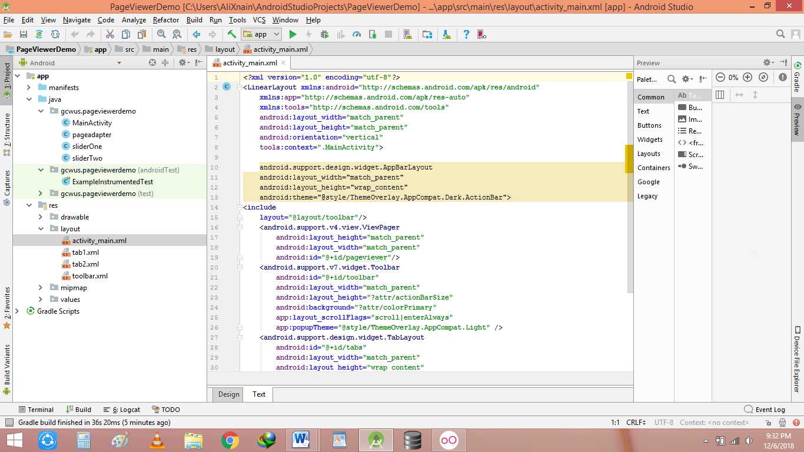

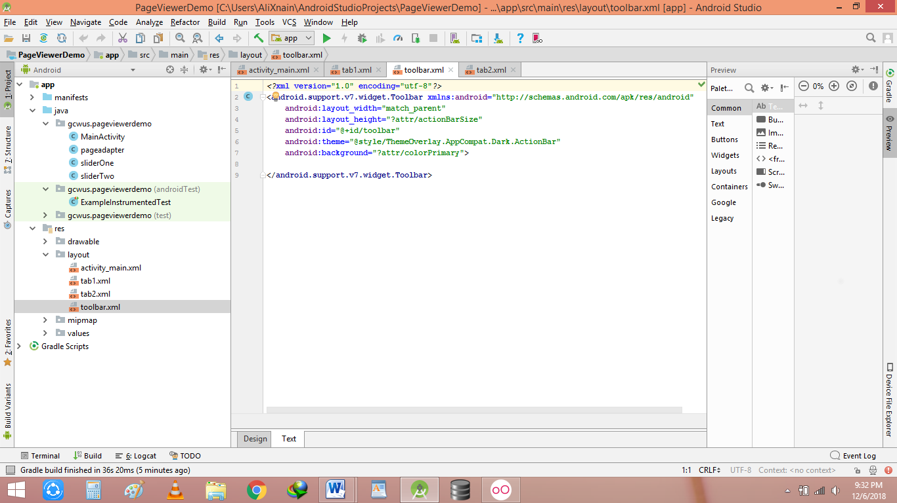

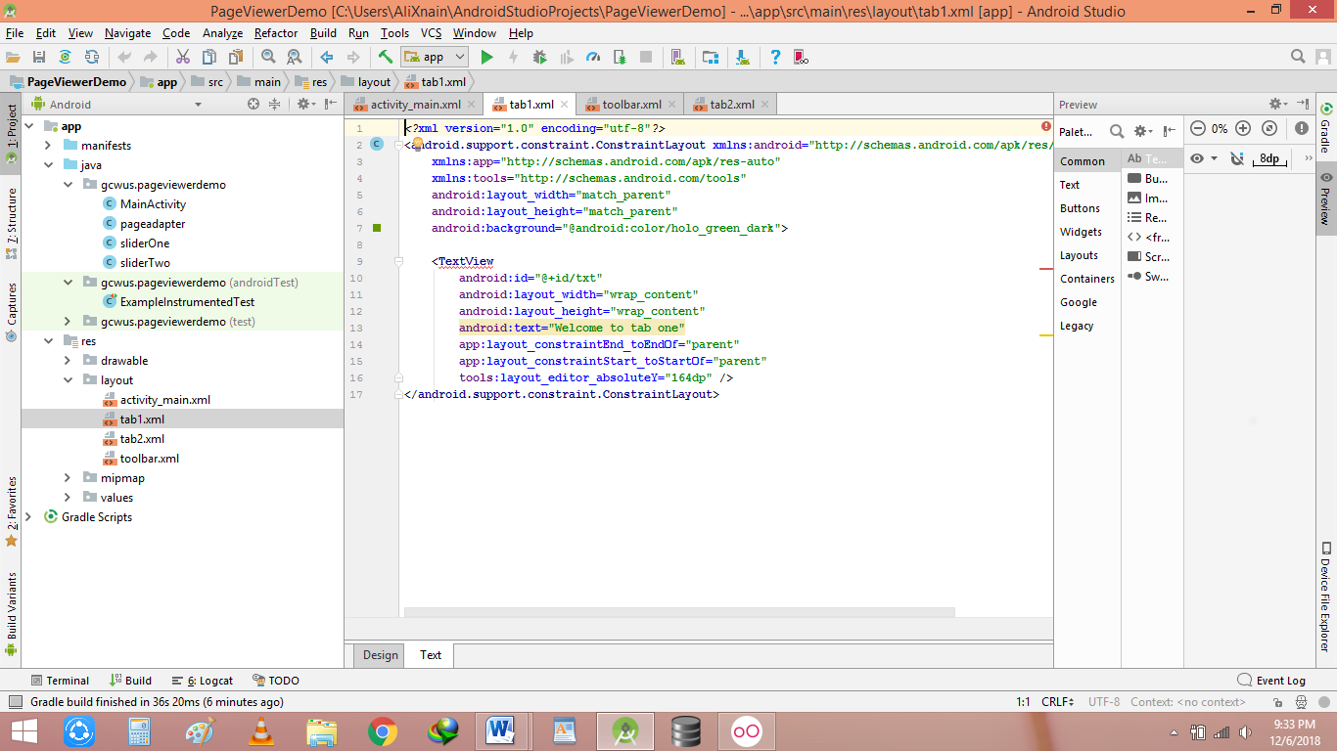

**Listview:**

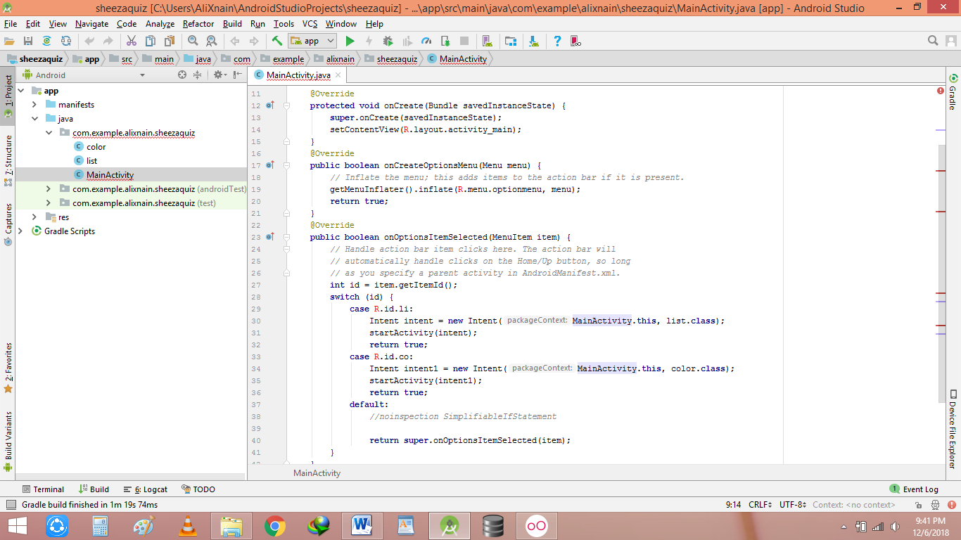

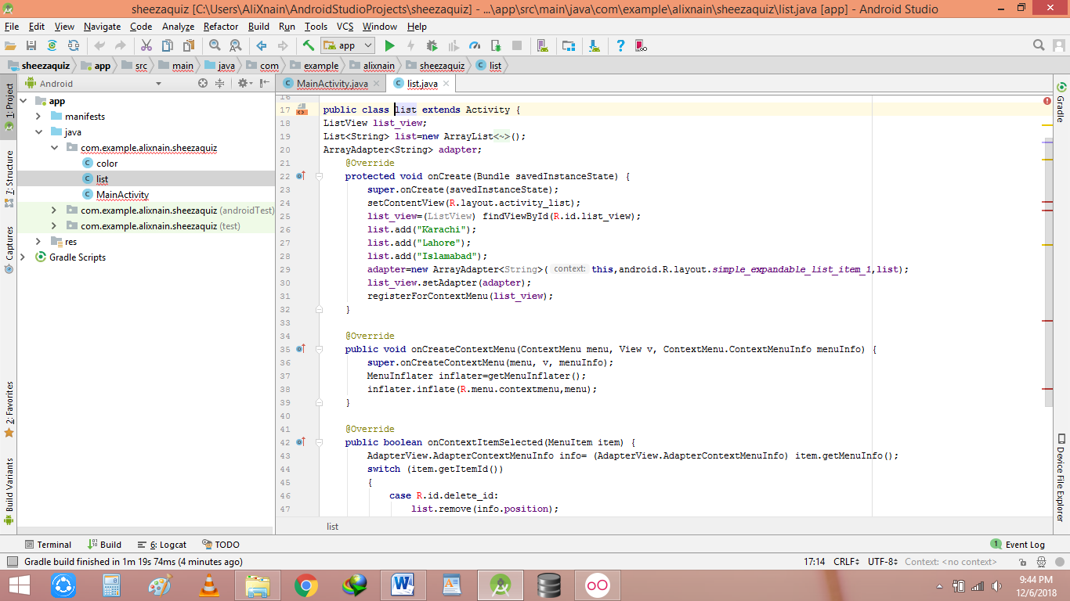

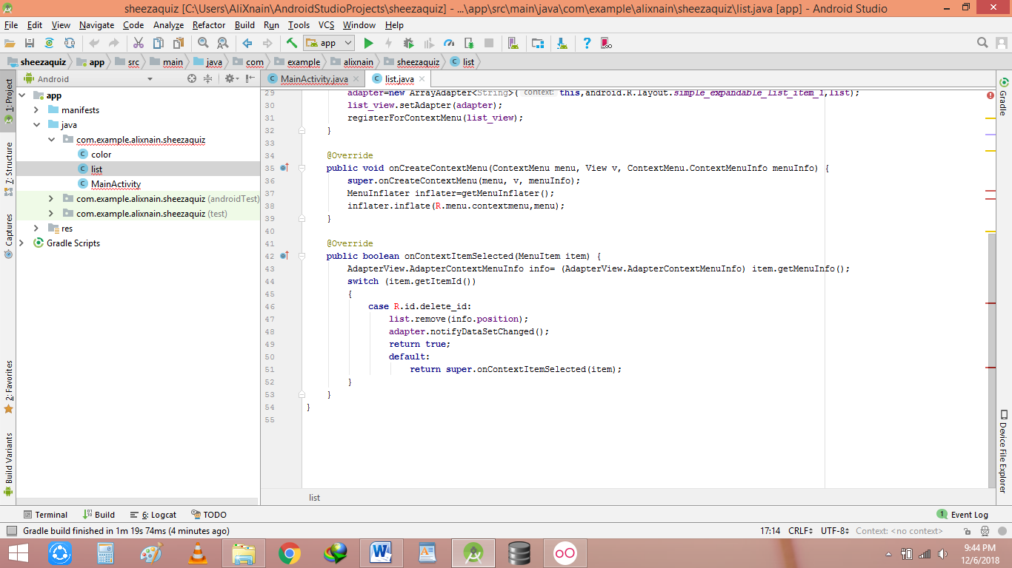

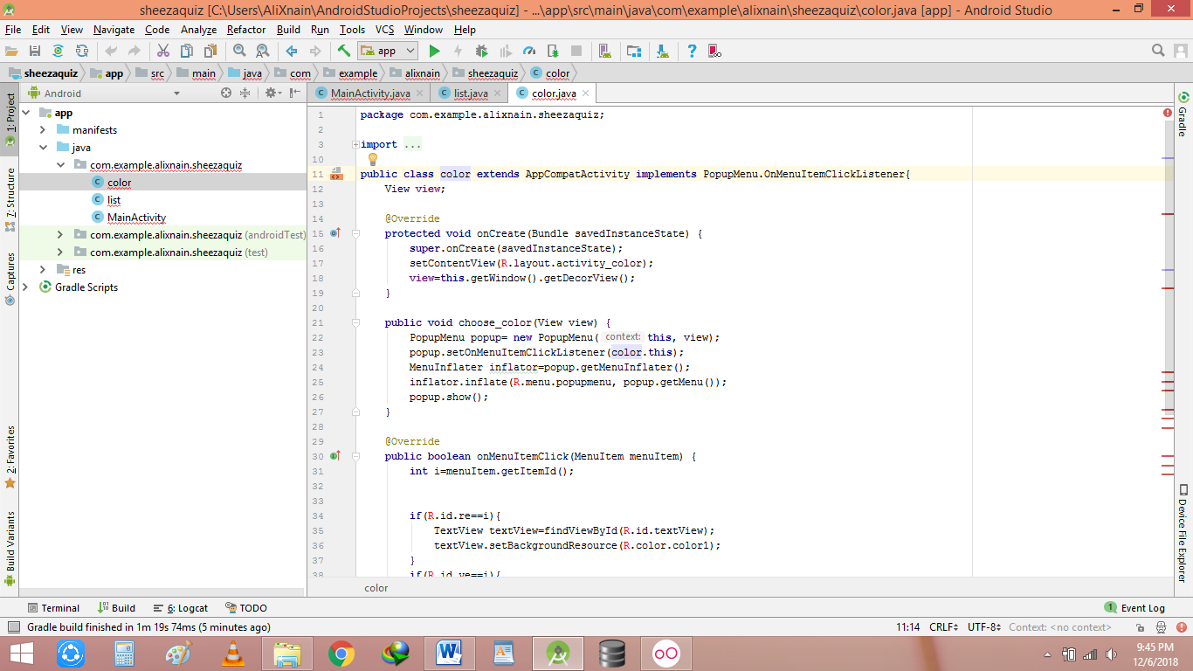

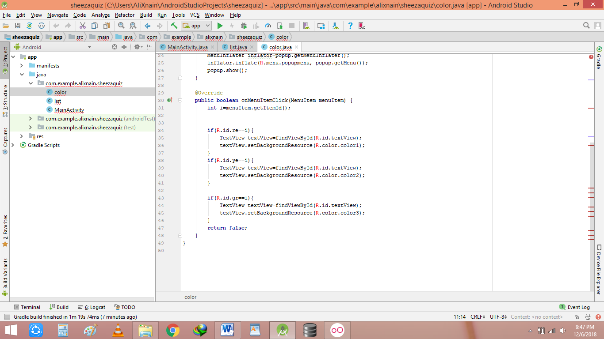

**Async task(internet connectivity):**

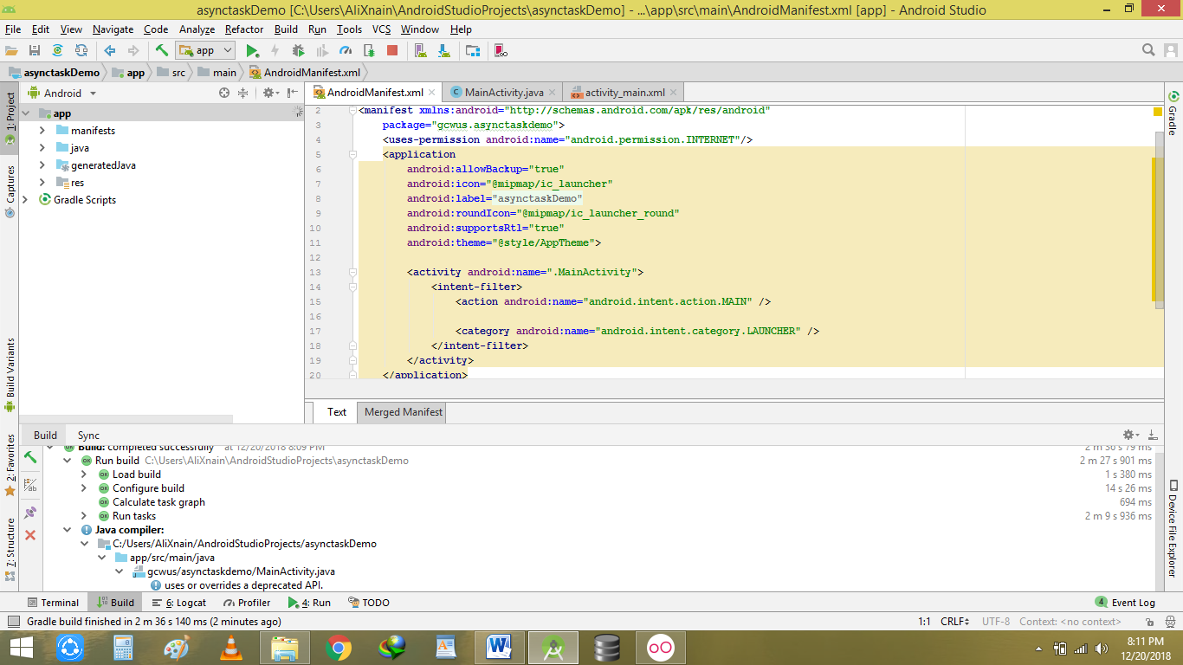

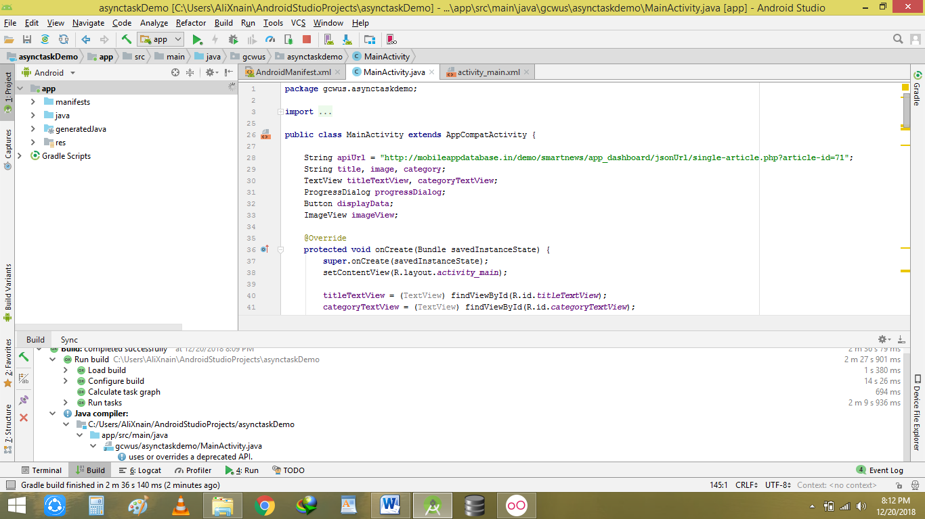

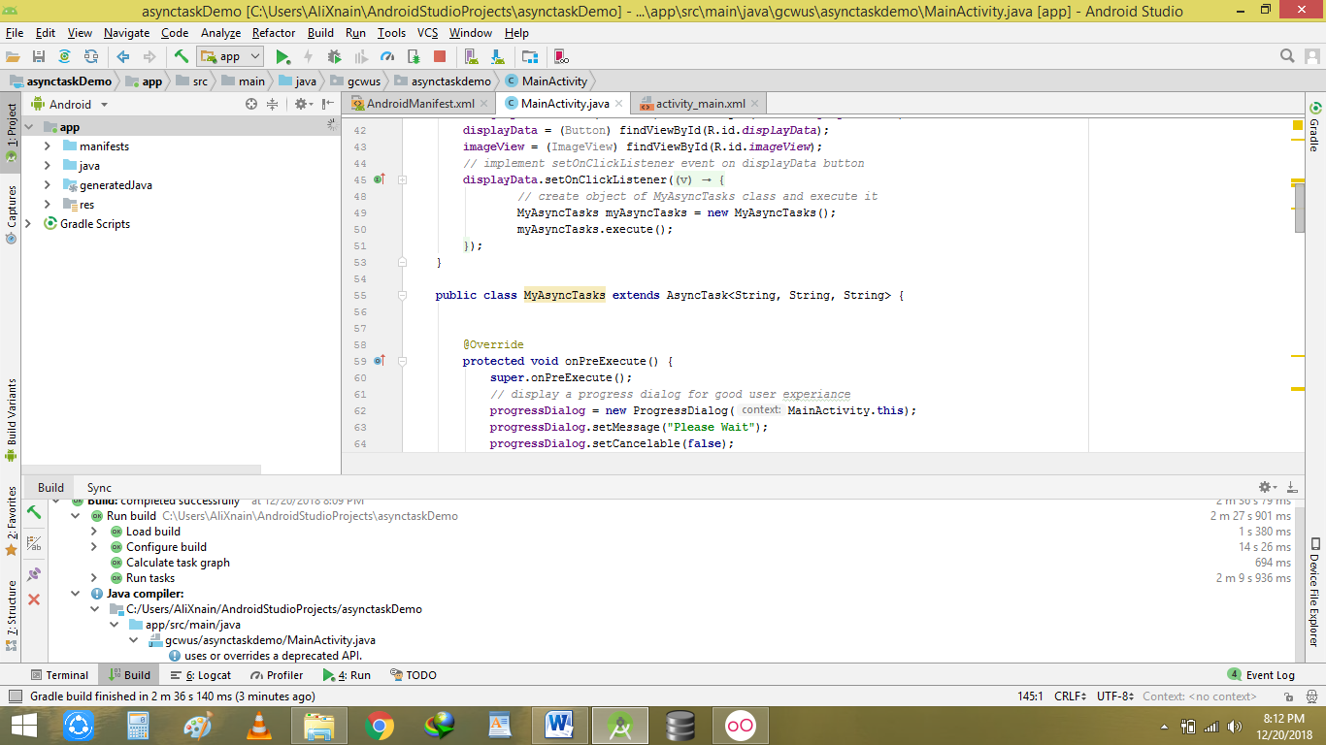

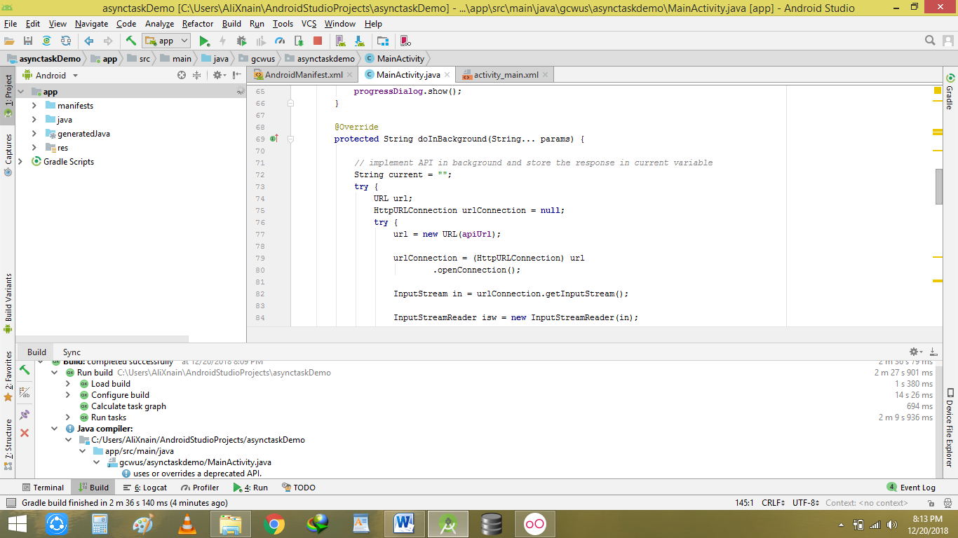

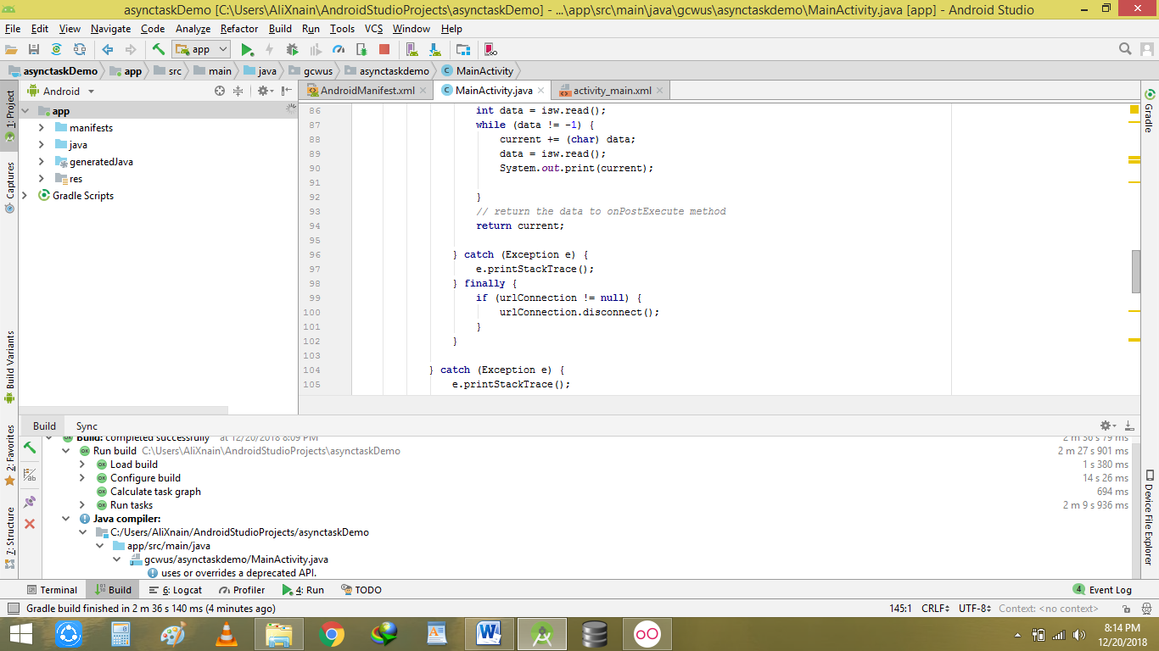

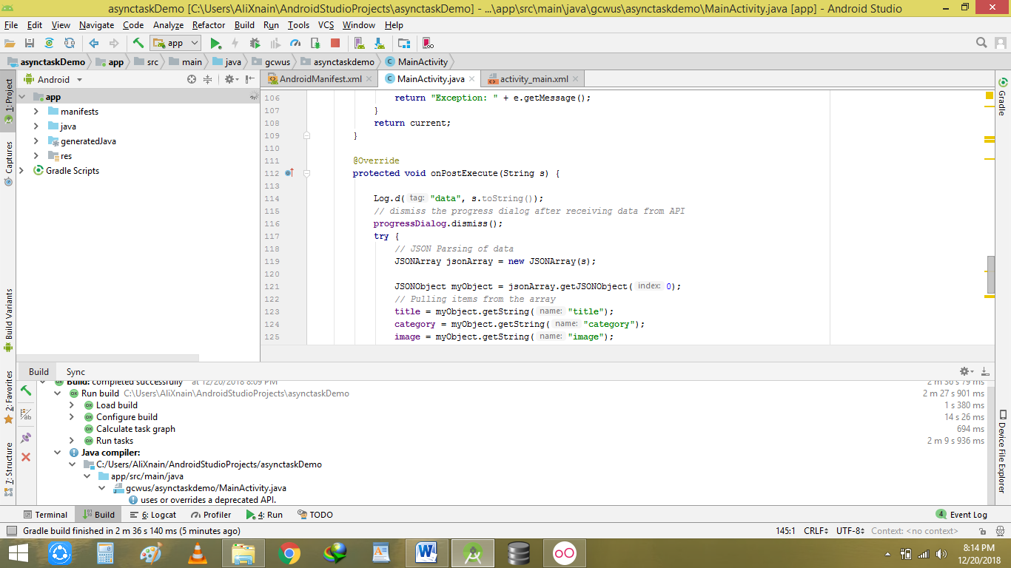

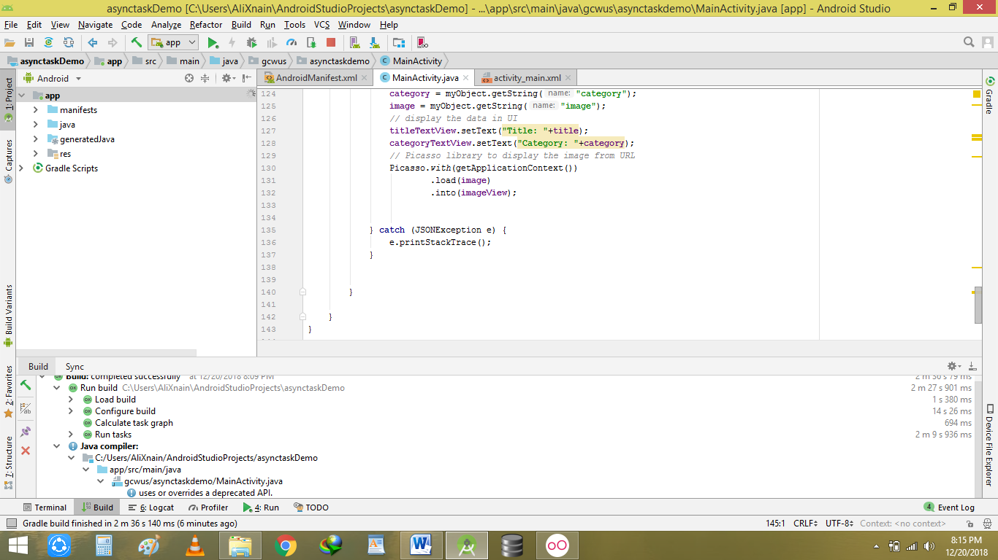

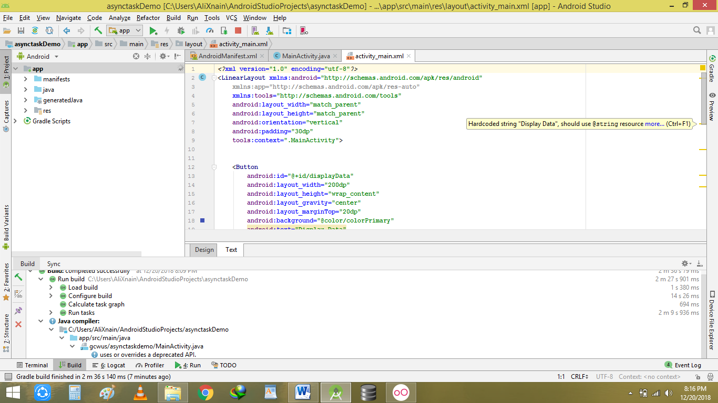

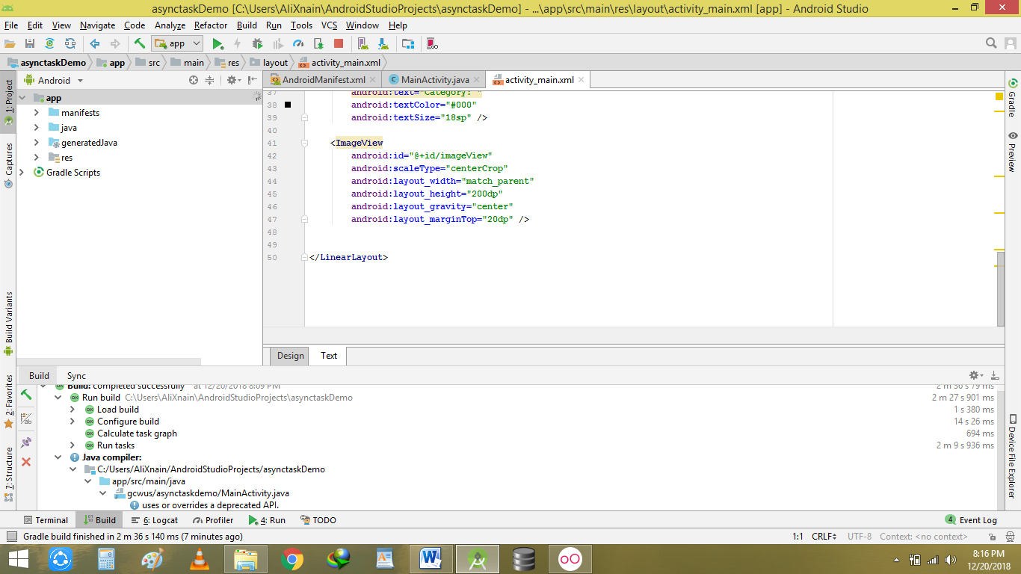

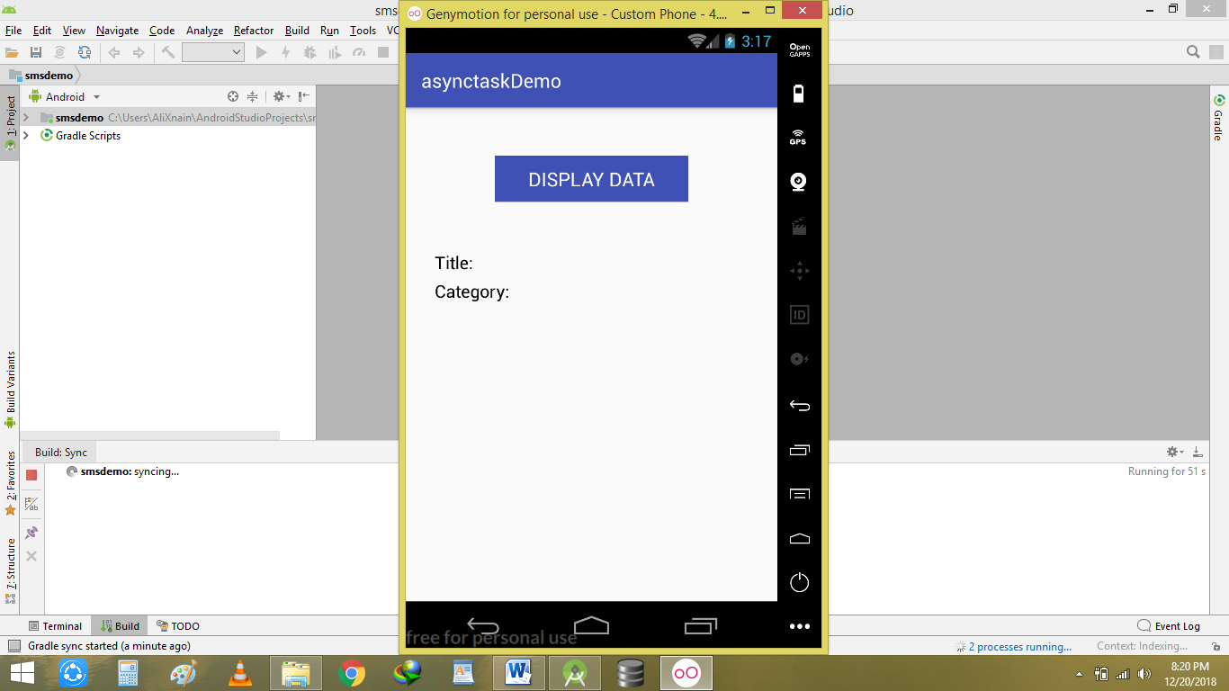It didn’t show pic coz of my very slow internet but u can see Wi-Fi signals are on the top. With fast net it will definitely work.

**SMS sending:**

